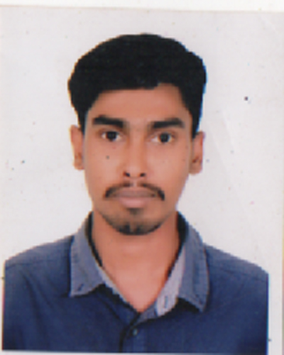
CURRICULUM VITAE
OF
MD. ASADUS JAMAN NAYEM
Mailing Address:
House- 109, Sector- 08,
Uttara, Dhaka-1230.

Cell: 01828-510566
E-mail: maj.nayem@gmail.com

Career Objective:

To obtain a responsible and challenging position where I can apply my studies, creativity and experiences into a practical situation that offers development opportunities for a career in an attractive environment.

Qualities:

- Ability to work independently with minimal day to day supervision.
- Ability to work under challenging and a term environment.
- Can work with people of all levels.

Educational Qualification:

- Diploma in Engineering:
Institute : Barisal Polytechnic Institute
Subject : Mechanical Technology
Result : 2.71 (out of 4.00)
Board : Technical Education Board
Year of Passing : 2015

- Secondary School Certificate (S.S.C)
Institute : Rajapur Pilot High School
Group : Science
Result : 4.31 (out of 5.00)
Board : Barisal
Year of Passing : 2010

Personal Information:

Father’s Name : Md. Ali Akabbar Khalifa
Mother’s Name : Mrs. Nazma Begum
Date of Birth : 10th July 1995
Gender : Male
Religion : Islam
Marital Status : Unmarried
Blood Group : O+ (ve)
Height : 5’-8”
Weight : 60 Kg
Nationality : Bangladeshi (By Birth)

Permanent Address:

C/O: Md. Ali Akabbar Khalifa
Vill: Baghri, P.O: Rajapur,
P.S: Rajapur, Dist: Jhalakathi.

Computer's Experience:

- Office package : Microsoft word, Microsoft Excel.
- Internet : E-Mail handling, Web browsing and surfing.

Language Skills:

- Bengali : Speaking, Reading, and Writing.
- English : Reading, Speaking and Writing.

Declaration:

I, the undersigned declare that the information specified in this Curriculum Vitae is true to the best of my belief and knowledge and correctly describes myself.

Experience:

Working as Sub Assistant Engineer at Akij Group, Dhaka Tobacco from December 1, 2016 to till now.

...............................................
Md. AsadusJaman Nayem
Date:

