CURRICULUM VITAE OF
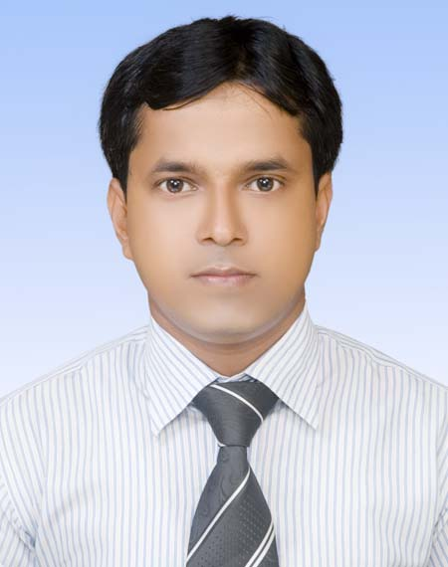

Sayedur Rahman
Mobile no: +88 01719041382
E-mail: srahman_me@yahoo.com

CAREER SUMMARY:

- A dedicated, result oriented candidate with seven years & eleven month of work experiences in mechanical engineering.
- Experience in variety of production, operation & maintenance activities.
- Experience in monitoring projects for cost, resource deployment, timeliness and quality work.
- Good knowledge of mechanical drawings and machineries layout.
- Well organised professional with an eye for details and excellent planning skills.

APPLICATION INFORMATION:

Year of Experience | : | Seven years & eleven months.
Looking for | : | Mid-level job.
Available for | : | Full time.

- Assembly In-charge (March 01, 2017 – Continuing)
HMCL NILOY BANGLADESH LTD. (Motorcycle manufacturing project),
Padmabilla, Shakharigati, Kotowali, Jessore.

Duties/Responsibilities:
- Act to achieve overall sales target.
- Prepare long & short-term strategic planning for production.
- Responsible for on time delivery of defect free fully assembled vehicles for Final Inspection and delivery
- Monitor production process and remove waste and constraints from process to improve efficiencies and enhance productivity.
- Preparing daily, weekly & monthly production & consumption report and submit to the authority.
- Responsible for product quality and process performance.
- In process defect analysis and to take corrective and preventive action.
- Educate & motivate the associates to maintain 5S activities in shop to make clean & healthy environment
- Co-ordinate in implementing preventive maintenance schedule of machine, jig, fixture to get smooth production of machines.

- Deputy Manager, Production (January 01, 2017 – February 28, 2017)
Runner Automobiles Ltd. (Motorcycle manufacturing project),
Paragaon (Barachala), Seed Store, Bhaluka, Mymensingh.

Duties/Responsibilities:
- Act to achieve overall sales target.
- Prepare long & short-term strategic planning for production.
- Monitor production process and remove bottle necks and system losses in the production to improve efficiency.
- Preparing daily, weekly & monthly production & consumption report and submit to the authority.
- Identify loopholes and weakness in manufacturing to increase production.
- To ensure Safety guidelines, Cleaning & House-keeping of the Production Floor as per SOPs.
- Prepare the maintenance schedule.
- Operation & maintenance hydraulic beam shearing machine.
- Operation & maintenance C-Frame mechanical press machine.
- Operation & maintenance Fretsaw tube cutting machine.

- Assistant Manager, Assembly (January 01, 2014 – December 31, 2016)
Runner Automobiles Ltd. (Motorcycle manufacturing project),
Paragaon (Barachala), Seed Store, Bhaluka, Mymensingh.

Duties/Responsibilities:
- Act to achieve overall sales target.
- Prepare long & short-term strategic planning for production.
- Responsible for on time delivery of defect free fully assembled vehicles for Final Inspection and delivery
- Monitor production process and remove waste and constraints from process to improve efficiencies and enhance productivity.
- Preparing daily, weekly & monthly production & consumption report and submit to the authority.
- Responsible for product quality and process performance.
- In process defect analysis and to take corrective and preventive action.
- Educate & motivate the associates to maintain 5S activities in shop to make clean & healthy environment

- Sr. Executive, Assembly (December 01, 2010 – December 31, 2013)
Runner Automobiles Ltd. (Motorcycle manufacturing project),
Paragaon (Barachala), Seed Store, Bhaluka, Mymensingh.

Duties/Responsibilities:
- Act to achieve overall sales target.
- Ensure implementation of production schedule efficiently.
- Submit report to authority every day for production, consumption, quality etc.
- Identify loopholes and weakness in assembly to increase production.
- Monitor quality & accuracy of product as well as attending daily meeting to rectify the faults.
- Lead the team, supervise and train the junior colleagues/workers/operators and helper.
- Maintaining the maintenance schedule & arrange periodic maintenance of machineries.
- To ensure Safety guidelines, Cleaning & House-keeping of the Production Floor as per SOPs.

- Assistant Engineer, Operation (January 01, 2010 – November 30, 2010)
GermanBangla Bicycles Ltd. (100% Export oriented company)
Joypura, Dhamrai, Dhaka.

Duties/Responsibilities:
- Prepare technical product specification.
- Implement production planning and production schedule.
- Plan & organise raw materials from store to ensure minimum waste and spoilage.
- Monitor quality, accuracy & timelines of all orders to ensure customer commitments.
- Ensure preventative maintenance of all production equipment.
- Raw materials sourcing, price negotiation & place purchase orders internationally.
- Communicate with the buyers & suppliers.

EDUCATIONAL QUALIFICATIONS:

Exam Title | Discipline | Name of Institution | University / Board | CGPA / Division | Year of Passing
B. Sc. in Engineering | Mechanical Engineering | Dhaka University of Engineering & Technology (DUET), Gazipur | DUET | 3.05  (In a scale of 4.00) | 2009  (December)
Diploma in Engineering | Chemical Technology | Dhaka Polytechnic Institute | B.T.E.B | 3.64 (Out of 4.00) | 2004
S.S.C | Science | Arra Kumed High School | Dhaka | First | 2000

COMPUTER LITERACY:

- Basics of Computer operation,
- Well versed with MS Word, MS Excel, MS Power Point and office package,
- Auto CAD.
- Solid Works.
- Internet Browsing & Email correspondence.
- ERP Software.

TRAINING ON:

- ISO 14001:2004 & OHSAS 18001:2007 (Internal Auditing Technique).
- ISO 9001:2008 (Internal Auditing Technique).
- Inventory Management.
- Supervisory Skill and Leadership Development.
- 5S & Productivity (NPO).

LANGUAGE PROFICIENCY:

Language | Writing | Reading | Speaking
Bengali | Excellent | Excellent | Excellent
English | Excellent | Excellent | Good

PERSONAL INFORMATION:

Father’s Name  Mother’s Name  Date of Birth  Sex  Religion  Marital Status  Nationality  Blood Group  Mailing Address  Permanent Address | : Abdul Hai  : Mrs. Tara Begum  : 15 June, 1983.  : Male  : Islam  : Married  : Bangladeshi by Birth  : A(+ve)  : 204/2 West Kafrul, Taltola, Dhaka-1207.  : Vill-Kodalia, P.O.- Singdair, P.S.- Nagarpur, Dist.-Tangail
CONFIDENCE:

- I am confident enough to face any type of challenge.
- I am sincere and up-to-date.
- I believe that it will be my constant endeavor and dynamic nature to make myself an appropriate specialist according to needs.
- I am smart, energetic and willing to work hard.

REFERENCES:

1.) Engr. Shahnewaz Hussain  Sr. General Manager  Runner Automobiles Ltd.,  (Runner Group of Companies)  Seed store, Bhaluka, Mymenshingh.  Contact No.: +88 01730405353.  E-mail: unit2_ral@runnerbd.com  Relation: Professional. |  | 2.) A.K.M. Rashed Zaman  Head of Material Management  HMCL NILOY BANGLADESH LIMITED  Padmabilla, Shakharigati, Kotowali, Jessore.  Contact No.: +88 01926790536.  E-mail: rashed.zaman@hmclniloy.com  Relation: Professional.

I understand that withholding pertinent information or giving false information in this resume will make me ineligible for the post or will make me liable to the dismissal. Bearing this in mind, I certify that the above statements and information are correct and complete

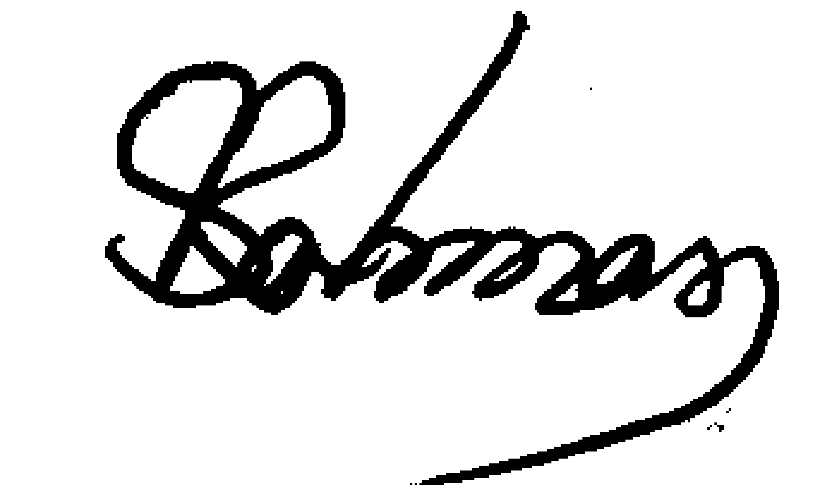
...................................

Signature

