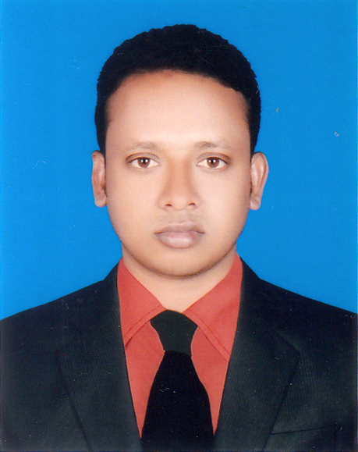
CURRICULUM VITAE
OF
MD. RAKIBUL ISLAM
Contact Number: 01722-721194

Objective

To work energetically in any environment where is an opportunity of self-assessment and improvement in both individual and group-based jobs that frequently faces various critical challenges and thrilling.

Scholastic Record

◩ Masters of Social Science (M.S.S Hon’s)
University : National University
Institute : Govt. Edward College, Pabna
Passed Year : 2013
Result : 2nd Class
Subject : Sociology
Duration : 1 Year
◩ Bachelor of Social Science (B.S.S Hon’s)
University : National University
Institute : Govt. Edward College, Pabna
Passed Year : 2012
Result : Second Class
Subject : Sociology
Duration : 04 Years
◩ Higher Secondary Certificate :

College : Atgharia College, Pabna
Board : Rajshahi
Passed Year : 2008
Result : GPA-4.50
Group : Humanities
◩ Secondary School Certificate :
School : Motijheel High School, Pabna.
Board : Rajshahi
Passed Year : 2006
Result : GPA-4.69
Group : Humanities
Language Proficiency

◩ Bangla & English (Reading, Writing, Speaking)
Computer Literacy

◩ Computer Operating : Computer Office Course Completed. MS. Word, MS. Excel, MS.
Power Point, Internet browsing etc.
INTEREST

◩ Reading & Writing, Computer Operating, Play (Cricket & Football), Traveling.

Name : Md. Rakibul Islam

Personal Details
Fathers Name : Md. Abdul Hakim Mollah
Mothers Name : Mst. Shefali Khatun
Date of Birth : 14th July, 1991
Place of Birth : Pabna.
Sex : Male

Nationality : Bangladeshi.
Height : 5´-4
Weight : 57 kg
Marital Status : married
Blood Group : AB⁺ (positive).
Religion : Islam
National ID No : 19917610531000002
Phone no : 01722-721194
Present & Permanent Address

◩ Md. Rakibul Islam
C/O: Md. Abdul Hakim Mollah
Village : Motighassa
Post : Motijheel Bazar-6610
Police station: Atgharia
District : Pabna.
Experience

1. I have three years experience as a manager at DISA NGO.
2.I have one year experience as an admin officer at DISA NGO.
3.I have three years experience as an assistant teacher at AGRONI MODEL SCHOOL & COLLEGE
in Gazipur.
REFERENCES:

◩ Md. Abdul Malek Mollah ◩ Md. Abul Kalam Azad
Ex. Chairman Lecturer in English
Debottar Union Council, Atghoria,Pabna Atgharia College, Pabna.
Cell: 01712953669 Cell: 01717-890630

I do hereby state that the above information is true and authentic.


--------------------------------------
Date: 20.07.2020 (Md. Rakibul Islam)
Declaration

