Md. Mehdi Al Shamim
Phone: 01711 32 58 40 Email: mehdialshamim2@gmail.com
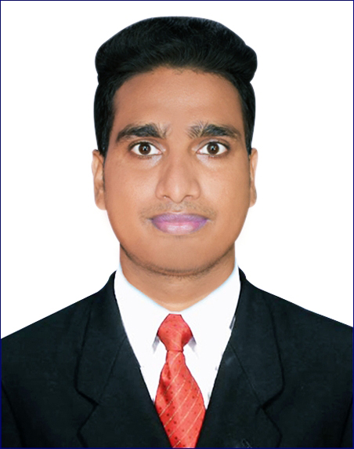

Career Objective:

To achieve the maximum output by providing well-judged performance and creating and exchanging benefits with the organization. I want to be the reliable hand of the organization to attain its goal and to build up my career.
Address:

Vill: Uttar Katia, Satkhira Sadar,
Satkhira, Bangladesh.

Date of Birth
January 01, 1992

Experience:

- Company: Laskar Group LTD. ( Satkhira )
Positive: HR Admin Officer and Customer Care
Joining Date: 03/10/19
Ending Date: 29/02/20
Duties/Responsibilities:
1. Checking Call Centre Reports
2. Checking Daily attendance book
3. Input time for late comers
4. Provide short leave token
5. Checking who is not inside office without permission
6. Documentation of leave applications
7. Create new documents like office order
8. Make sure everyone knows about office order
9. Check who is doing personal business instead of official work
10. Processing Training
11. Any other task given by management

- Company: LOCKPUR GROUP LTD. ( Bagerhat )
Positive: Assistant Admin Officer (HR)
Joining Date: 01/11/17
Ending Date:. 30/06/19
Duties/Responsibilities:
1. Preparation of employee personal files and ensures proper maintenance of the same
2. Prepare and maintain an archive of the personnel folders
3. Maintaining human resource database by recording joining, transfers, terminations,
changes in job
4. Classifications, merit increases, tracking vacation and in leave
5. Handle Employee Grievance & inform Management as early as possible
6. Prepare Office Order/Notice
7. Any other responsibility assigned by the Management
- Company: IFIC BANK LTD. ( Satkhira )
Position: Trainee Sales Officer
Joining Date: 23/06/2016
Ending Date: 31/10/2017

Duties/Responsibilities:
Retail Banking, Marketing & Sales as in FDR, DPS, Account opening Card opening etc.

- Company: Grameenphone Ltd. ( Jessore )
Position: Customer Manager
Joining Date: 01/01/2016
Ending Date: 31/05/2016

Duties/Responsibilities:
Customer Service & Relationship, Sales & Marketing etc.

Personal Skills:

- Excellent written and verbal communication skills
- Highly organized and efficient
- Ability to work independently or as part of a team
- Proven leadership skills and ably to motivate
- Labor law

Technical Skills:

- Microsoft Office (MS Word, Excel, PowerPoint, Internet, etc.)
- Adobe Creative suite (Photoshop, In Design, After Effects, Dream weaver)

Language:

- Good command over both in Bengali & English

Educational Proficiency:

MBA ( Master of Business Administration )

University : North Western University, Khulna
Group : MBA (HRM)
Institute : North Western University
CGPA : 3.25/B+ (In a 4.00 scale)
Passing Year : 2017

BBA (Bachelor of Business Administration):
University : National University
Group : BBA (Major in Marketing)
Institute : Sunderban Science & Business College
CGPA : 2.81/B- (In a 4.00 scale)
Passing Year : 2015

H.S.C (Higher Secondary Certificate):
Board : Jessore
Group : Science
Institute : Satkhira Govt. College, Satkhira
CGPA : 3.50/A- (Out of 5.00)
Passing year : 2009

S.S.C (Secondary School Certificate):
Board : Jessore
Group : Science
Institute : Satkhira Govt. High School, Satkhira
CGPA : 4.25/A (Out of 5.00)
Passing year : 2007

Hobbies and interest
- Banking
- Reading books, novel, articles, watching movies
- Traveling at historical place

Personal Data:

Name : Md. Mehdi Al Shamim
Fathers name : Md. Mostafa Ferdous
Mothers name : Mrs Rowshan Ara
Present Address : Vill: Uttar Katia, Satkhira Sadar, Satkhira
Permanent Address : Vill: Uttar Katia, Satkhira Sadar, Satkhira
Date of birth : 01 January 1992
Sex : Male
Religion : Islam (Sunni)
Nationality : Bangladeshi
Blood Group : O +
Marital Status : Married
Spouse Name : Syeda Hasnin Nobi
National ID No : 325 262 4956
Contact No : 01711 32 58 40

Reference:

A.K.M. Sayeed Hossain Md. Aktarujjaman
Joint Director Joint Director
Bangladesh Bank Bangladesh Bank
Head Office Head Office
E - mail : sayeed.hossain@bb.org.bd E - mail : actaruzzaman@bb.org.bd
Cell No: 01712 60 96 80 Cell No: 01970 27 24 35
Relation: Uncle Relation: Cousin

Declaration:

I hereby declare that the above written particulars are true to the best of my knowledge and belief.


Signature & Date:

