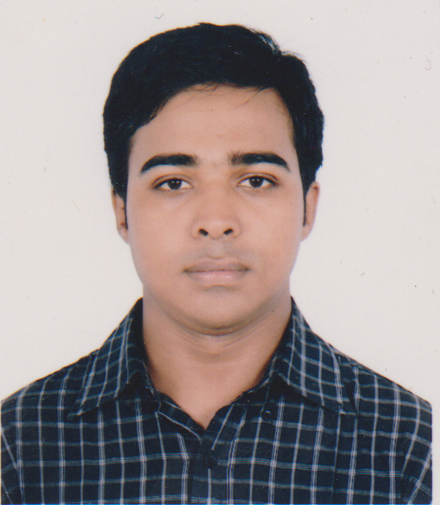
MD. RASHED KHAN BABU
House no: 72, Arambagh,
Motijheel, Dhaka-1000
Cell number: 01988196643
Email: baburashed22@gmail.com

Career Objective:

Looking forward to a challenging career in the professional world where I would be able to utilize my knowledge and skills through dedication, challenge and growth-oriented activities.
Key Strengths:

- Efficient in preparing reports and delivering presentations.
- Have the ability to work independently as well as in a team and can motivate people.
- Fast learner in changing environment.
- Can work in under pressure.
- Self-motivated and honest.

Academic Records:

- Bachelor of Business Administration (BBA), 2018
American International University Bangladesh (AIUB)
Major in Human Resource Management
CGPA: 2.91 (out of 4.00)
Credits completed: 126 credits (out 0f 126)
- Higher Secondary Certificate, 2013
BAF Shaheen college Tejgaon, Dhaka
GPA: 4.60 (out of 5)
Group: commerce (Dhaka Board)

- Secondary School Certificate, 2011
Bangladesh bank high school,motijheel, Dhaka
GPA: 4.31 (out of 5)
Group: commerce (Dhaka Board)

Computer skills:
- Well conversant with PC packages such as MS-Word, MS-Excel, MS Power Point.
- Training from National youth training center.

Language skills:

- Fluent in Bengali and English.

Personal Details:
Father : Md. Ramiz Uddin
Occupation : Govt service holder
Mother : Parvin Begum
Occupation : Housewife
Date of birth : 15-02-1996
Nationality : Bangladeshi
Religion : Muslim
Sex : Male
Blood Group : A+
Marital status : Single
Permanent address : 72,Arambagh,motijheel,Dhaka-1000

