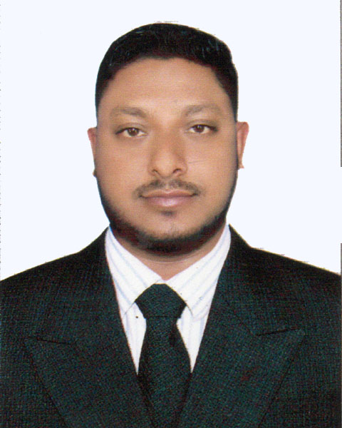
CURRICULAM VITAE
OF
Gazi Md. Tajmir Hassain
C/O: Gazi Md. Harun ar Rashid
Address: Haji Mohammad Mohashin Road,
Doulatpur, Khulna
Cell Phone: 01400069898.
E-mail: banglalion.tajmir@gmail.com
OBJECTIVE:
To work as a part of dynamic team where not only spirit and innovation but also sincerity and honesty will be highly valued with learning opportunity at the time of achieving organizational goals.
EDUCATIONAL ATTACHMENT:
Bachelor of Business Admonition (B.B.A):
- Institution : Govt. B.L. College.
- Board/University : National University.
- Group/ Subject : Accounting
- Passing Year : 2015
- Result : 2 Division
Higher Secondary Certificate (H.S.C):
- Institution : Govt. B.L. College.
- Board/University : Jessore.
- Group/ Subject : Humanities
- Passing Year : 2010
- Result : 3.80
Secondary School Certificate (S.S.C):
- Institution : Hazi Mohammad Mohashin High School
- Board/University : Jessore.
- Group/ Subject : Humanities
- Passing Year : 2008
- Result : 4.50
Highlights of Qualification
- Excellent Organizational, interpersonal and communicative skills.
- Team sprit initiative and able to work under reassures.
- High sense of motivation and dedication.
- Able to bear extreme physical and mental stress and to solve strong analytical problem
COMPUTER SKILLS:
- Knowledge in operating systems-Windows 98 and XP, Windows 2007.
- Knowledge in Microsoft Office.
- Knowledge on Internet browsing and e-mail.
LANGUAGES PROFICIENCY:
- Fluent in reading, writing, listening & speaking English.
- Fluent in reading, writing, listening & speaking Bengali.
INTERESTS:
- Internet browsing, Journey, Reading Novel, Meet new person etc.
Experience :
- From April 2010 to December 2011 (1 Years) Work Experience as a Customer Care Manager in Banglalion Wimax (Dhaka).
- From January 2012 to 2013 now work experience as a Businesses Development Supervisor I Group (Intragra Group) Deens Mobile (Samsung Mobile), Zen International Ltd. (bKash), Compugats (Robi),Vision Services Ltd (Dutch Bangla Mobile Banking-Rocket), (Dhaka).
- Nokia Full time job as a Brand Promoter Supervisor(2013) (Dhaka)
- OPPO Full time job as a Brand promoter Monitor And Trainer (2014) (Dhaka)
- From January 2015 Samsung Experience Consultant As a Samsung Consumer Electronics (Dhaka)
- 1st January, 2016 As a Territory Sales Officer in Sales Operation Management Samsung Consumer Electronics. (Dec 2019) (Faridpur)
- 1st January, 2020 As a Territory Manager in Sales Operation Management Project Of Fair Electronics (Samsung Consumer Electronics).(Satkhira). (April 2020)
- 1st May, 2020 As a Area Manager in Sales Operation Management Project Of LG Electronics .(Bogura, Dinajpur, Dhaka North). (Till Now)
SELF ASSESSMENT:
- Communicative and friendly.
- Enthusiastic, good negotiator.
- Lead people towards the objective.
- Capable of working in stressful environment.
- Passion for learning, willing to take challenges.
- Outstanding flexibility & adaptability with changes
- Self motivated for learning & taking responsibilities :
PERSONAL DETAILS:
Fathers Name : Gazi Md. Harun ar Rashid
Mothers Name : Mim Begum
Permanent Address : Haji Mohammad Mohashin Road,
P.S: Doulatpur, Dist: Khulna.
Date of Birth : 09/11/1993
Nationality : Bangladeshi
Religion : Islam
Sex : Male
Marital Status : Married
Blood Group : A positive
Height : 55”
Declaration
I do solemnly affirm that the information contained herein is correct to the best of my knowledge and belief. If any false or incorrect information is quoted from this curriculum vitae, under signed will be liable and take full responsibility.



(Md. Tajmir Hossain )

