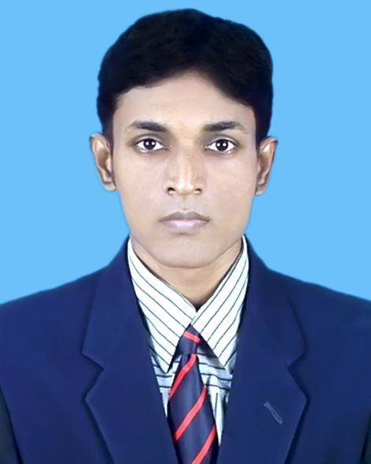
CURRICULUM VITAE

Abdullah Al Mamun
E-mail: Shahin.me07.ruet@gmail.com
Contact No: 01715587576
LinkedIn : abdullah-al-mamun-550b84143
B.Sc. in Mechanical Engineering.
Rajshahi University of Engineering & Technology,RUET.
Rajshahi-6204

Career Objective
- Looking a Challenging Job in the field of Mechanical engineering to build up my strong career.
- To work hard for better Tomorrow.
- To plan and make schedule to obtain the company goal.
- To Convert my internal potential into work and to develop the company.

Experience

Company Name | Location | Designation | Duration | Year of Experience
Confidence Group | Dhaka Kawran  Bazar | Sr.Executive | 01.03.19 to  Continue | 1 year  6 Month
Runner Group | Dhaka Banani | Sr. Executive | 01.06.17 to 28.02.19 | 1 year  9 Month
Nitol-Tata Group | Dhaka Tejgaon | Sr.Service Engineer | 03.12.14 to  30.04.17 | 2 year  5 Month
LSI Group | Dhaka EPZ,Savar | Assistant Manager | 01.01.13 to  31.10.13 | 10 Month

Educational Qualification

Exam Tittle/Degree | University/College/School | Bord | Passing Year | CGPA
B.sc in Mechanical Engineering | Rajshahi University of Engineering & Technology, RUET. | Rajshahi | 2011 | 3.00
H.S.C | Rajbari Govt. College, Rajbari | Dhaka | 2006 | 4.40
S.S.C | Rajbari Govt. High school, Rajbari | Dhaka | 2004 | 4.81

Skills
Operating systems known: Windows XP.
Other Packages: MS Word,Excell,MS Power Point, and Internet browsing.
Package programme: Solid works.
- Turbo C
- AUTOCAD
- Computer Networking,Computer Trouble shooting

Language proficiency

- Writing, speaking & listening skill in English.
- Understanding competent in Hindi .
- High communicative compitence in English.

Major subjects in B.Sc. Engineering

- Thermodynamics
- Fluid Mechanics
- Fluid Machinery
- Machine Tools
- Engineering Mechanics
- Heat & Mass Transfer
- Automobile engineering
- Industrial Management
- Production Planning & Control
- Quality Control & Material Handling
- Power Plant
- Basic computer programming Engineering
- Production Process
- Design of Machine Elements
- Mechanics of solid
- Refrigeration and Air Conditioning
- Engineering Metallurgy

Thesis and Project title
- Waste Transformer oil as an alternative fuel for Diesel Engine.

Thesis Supervisor
Professor Dr. Md. Nurun Nabi
Dean,Faculty of Mechanical Engineering.
Rajshahi university of Engineering and Technology,RUET.

Industrial Training

Industrial Training in Bangladesh Industrial Technical Assistance Centre (BITAC) at Tejgaon,Dhaka for 30 days.

Personal Details

Name: Abdullah Al Mamun
Fathers name: Md.Moyej Uddin Mia
Mothers name: Shefaly Ahmed
Permanent Address: Abdullah Al Mamun
C/O: Md. Moyej Uddin Mia
Vill: 3 No. Baradangga,Hospital Road,Rajbari.
Post: Rajbari
Thana: Rajbari
Dist: Rajbari
Bangladesh
Date of Birth: 06.12.89
Nationality: Bangladeshi
Sex: Male
Religion: Islam
Marital Status: Single

References

Professor Dr. Md Nurun Nabi  Dean,Faculty of Mechanical Engineering,RUET  Mob.01721750832  Email:nahin1234@gmail.com | Lt. Colonel Rezaul karim Reza  Dhaka Cantonment, Dhaka.  Mobile.01769096389  Email.Reza.6389@yahoo.com

Declaration

I declare that all the above information given here is accurate and up-to-date.

Date: Abdullah Al Mamun
01.06.2020

