Piklu Biswas
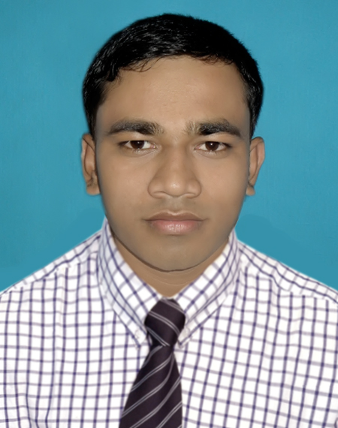
35, Kabi Jasim Uddin Road,
Kamlapur, Motijheel
Dhaka-1217
Contact: 01749-472703
E-mail: piklubiswas2@gmail .com

Career Specification

Providing the best quality of performance to accomplish the goal of the organization with utmost care, as well as to achieve the professional skill and expertise for the betterment of the organization

Education
Bachelor of Business Administrative (BBA) -2013 -2014
BBA Final year ; Major: Management
Govt. Shahid Suhrawardy college , Dhaka

Higher Secondary Certificate (HSC)- 2013
GPA  3.70 (A-) ; Business Studies
Agailjhara degree college, Barisal.

Secondary School Certificate (SSC) -2010
GPA  3.81 (A-) ; Business Studies
Askar Kalibari high school.

Computer proficiency

- Operating System Windows xp, Windows Vista
- Microsoft Office 2003, 2007 (MS-Word, MS-Excel, MS-Power Point , MS-Access)
- Internet & Website Browsing.
- Sound knowledge about different technique
- Hardware Assemble & Software Installation.

Language Skill

- Bangla  Base Language
- Moderate command in written & spoken English communication.

About me

Self-assessment:
Adaptable to change, Leadership proficiency, Sincere to assigned work, Can work under pressure, Positive spirited, Can work as a team player and self-confident.

Hobbies & Interests:

- Music
- Reading
- Traveling
- Work for Society

Personal details:

- Father : Krisnakanta Biswas

- Mother : Pabitra Biswas

- Date of Birth : August 20, 1995.

- Place of Birth : Vill- Askar, P,O- Askar Kalibari, P.S.-Agailjhara, Dist-Barisal.

- Religion : Hindu

- Nationality : Bangladeshi

- Blood Group : 0⁺ ve

References
Md. Enayet Ullah
Assistant Vice President
Contact: 01714008299
E-mail: enayet.ullah@mutualtrustbank.com

. ..
(Piklu Biswas)

