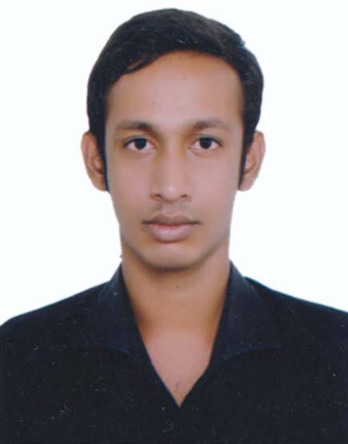
Curriculum Vitae

KAOSER MAHAMUD
C/O : Abdul Latif
Contact no. : +88 01825645811
E-mail : kaoser8@gmail.com
Career Objective
I am looking for a hard and challenging job where I will have the scope to utilize my knowledge and skills for the development of the institution. I believe I will perform any task honestly as my goal.
Academic Qualification
Started from most recent degree:

- Name of Degree: M.B.A
Name of University : National University
Name of Institution : Dinajpur Govt. College, Dinajpur
Discipline : Accounting
Result : GPA 3.20 in the scale of 4.00
Passing Year : 2019

- Name of Degree: B.B.A (Hons)
Name of University : National University
Name of Institution : Dinajpur Govt. College, Dinajpur
Discipline : Accounting
Result : GPA 3.14 in the scale of 4.00
Passing Year : 2016

- Name of Degree: Higher Secondary Certificate (HSC)
Name of Institution : Dinajpur Govt. Commercial Institute, Dinajpur
Board : Dhaka
Discipline : Business Studies
Result : GPA 4.86 in the scale of 5.00
Passing Year : 2012

- Name of Degree: Secondary School Certificate (SSC)
Name of Institution : Bontara (Balupara) High School, Dinajpur
Board : Dinajpur
Discipline : Science
Result : GPA 4.50 in the scale of 5.00
Passing Year : 2010

Computer Knowledge
- Operational System : Windows XP, Windows 7
- Database Languages : MS Office.

Language Skills
- Bengali : Mother Tongue
- English : Reading, Writing and Speaking fluently.
Strength
- Patient, honesty and positivism.
- Creative thinking, dedication and hard working.
- Self motivated and strong concern for career.
- Good leadership skill.

Training
- Training Course on “Computer Office Application” from IT Vision, Dinajpur. Duration: 6 Months.

Employment History
- Management trainee officer : Unimas Sportswear Ltd. Mainland Town
Address:Bagbari,Kashimpur,Gazipur-1700
Duration:01/12/2019 to till now

Personal Information
- Name : Kaoser Mahamud
- Fathers Name : Abdul Latif
- Mothers Name : Kulsum Begum
- Permanent Address : Vill : Gangaprashad, P.O. Laxmitola
P.S : Dinajpur Sadar, Dist : Dinajpur.
- Present Address : Vill : Gangaprashad, P.O. Laxmitola
P.S : Dinajpur Sadar, Dist : Dinajpur.
- Date of Birth : 20 September 1994
- Sex : Male
- Nationality : Bangladeshi (By birth)
- Blood Group : B ^{(ve+)}
- Height : 5 feet 6 inch.
- Marital Status : Single
- Religion : Islam
- National ID No : 9121317391

Declaration

I hereby, declare that the above information in the resume is true and correct to the
best of my knowledge and behalf.

Signature :
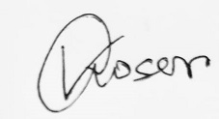

Kaoser Mahamud

Date : 09/02/2021

