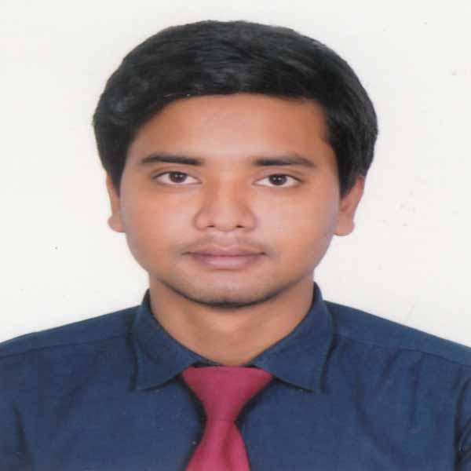

CURRICULUM VITAE OF

SABBIR ALAM CHOWDHURY
Phone- +8801743727210
+8801812141154
E-mail:sabbir92.alam@gmail.com
CAREER OBJECTIVES
To pursue a challenging career in a leading and well-reputed organization where enthusiasm, sincerity, honesty, hard working, excellent environment and motivational factors will help and support me to utilize my knowledge and expertise for professional development.

PERSONAL INFORMATION
Name : Sabbir Alam Chowdhury
Father’s Name : Abdul Baten Chowdhury
Mother’s Name : Firoza Begum.
Mailing Address : Sabbir Alam Chowdhury
House: 10, Road: 01
Shekhertek, Mohammadpur,Dhaka.

Permanent Address : Vill- Ichail P.O- Bogdour-hat
Upazila- Kaharol
Dist- Dinajpur.
Date of Birth : 18September, 1992
Marital Status : Unmarried
Religion : Islam (Sunni)
Nationality : Bangladeshi (by birth)
National ID : 19922715694000195
Blood Group : A(+ve)

EXPERIENCE

- Work in “Bangladesh Development Bank Ltd.”(BDBL) from 6thMarch, 2016 to 26 April 2016 as internship
- Work in “Paradise Engineering Ltd” as Marketing Officer from 1st June 2016 to 30th October 2017 in Rangpur Division.

EXTRA CURRICULAM ACTIVITIES
- Interested in cricket, football & badminton.
- Familiar with creative writing as well as experience in report writing.
- Familiar with presentation as well.

LANGUAGE PROFICIENCY

- Fluent in Bengali (Native).
- Fluent in English(Reading, Writing, Speaking).

COMPUTER LITERACY

- Proficient in MS-Word, MS-Excel,MS -Access.
- Internet Browsing, E-Mail.
- Social Networking.

EDUCATIONAL BACKGROUND

Examination Name | Institute | Department | Result | Passing Year
BBA | University of Asia Pacific | Marketing | 2.98 | 2016
HSC | Dinajpur Adarsha College | Science | 3.60 | 2010
SSC | Uttar Madhabpur High School | Science | 4.44 | 2008
REFERENCE

1. Md. Istiak Uddin
Assistant Professor
Business Administration
University of Asia Pacific
Istiak.edu@gmail.com
Mb. 01755000013
2. Kamrul Hasan Khan
Asst. Facility Manager
HANSA Management Ltd
kamrul@unique-hansa.com
Mb.01515637682

.
DECLARATION

I hereby, declare that the statements made by me in the curriculum vitae are true, complete and correct to the best of my knowledge and behalf.


……………………….
Sabbir Alam Chowdhury
Date:

