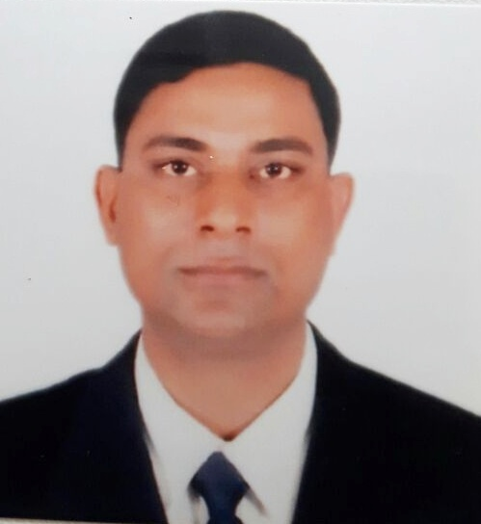

Resume of

Masudur Rahman

Contact Address: 26/1, Level -2, Arjat Para, Mohakhali, Dhaka.
Phone 01714-130297

Career Profile:

- Highly talented and accomplished professional with 18 years of work experience in Two wheeler industry
- Experience of managing retail and dealer sales.
- Successfully supervised and assisted sales personnel in the dealer and to achieve their given target.
- Experienced with implementing various marketing and promotion strategy to increase market share and retain existing customers.
- Already visited 60 district and maximum Prominent thana in Bangladesh

EMPLOYMENT HISTORY

- From 7th September 2013 to Till date
Company Name : Aftab Auto Mobiles Ltd. A Navana Concern
Designation : Senior assistant Manager, New dealer recruitment (Under sales department)

- From 3rd July, 2006 to 30th December 2012.
Company Name : Panorama motors Ltd.
Designation : Area Manager, New dealer recruitment and recovery (under sales department)
Zone : Dhaka, Sylhet, Chittagong

- From 20th March, 2000 to 1st June 2006.
Company Name : Uttara Motors.
Designation : Senior Executive (Eskatan branch)
Zone : Dhaka Division

- From 5th March, 1997 to 30th December 2000.
Company Name : H.S Enterprise
Designation : Branch Inspector
Zone : Dhaka Division

LANGUAGE SKILLS

Fluent in reading, writing and speaking Bengali, English conversationally

COMPUTER SKILLS
- MS Office Application, Internet, Browsing, E-mail, can work on all operating system.

TRAINING

New dealer recruitment process and recovery needs first “organized by Corporate HR Division, Navana Group”

EDUCATION

- Course Name : M.S.S
Institute : University of Dhaka
Major : Sociology
Year of Pass : 1995

- Course Name : B.S.S.
Institute : University of Dhaka
Major : Social Science
Year of Pass : 1990

- Course Name : H.S.C
Subject : Arts
Board : Dhaka Board
Year of Pass : 1988

- Course Name : S.S.C
Subject : Arts
Board : Dhaka Board
Year of Pass : 1984

SPECIAL SKILLS
- Excellent knowledge of all automobile products
- Excellent management and supervisory skills
- Responsible in performing task in a safe and accurate manner
- Expert in team working and building skills

PERSONAL PROFILE

- Father’s Name : Md. Gias Uddin.

- Mother’s Name : Haowa BIBI.

- Contact Address : Village-Pariata, P.O-Bathkura, P.S-Dhanbari, Dist- Tangail.

- Contact Number : 01714130297
- Date of Birth : 11th February 1969
- Nationality : Bangladeshi
- Marital Status : Married
- Religion : Muslim

Md. Masudur Rahman

