Curriculum Vitae of
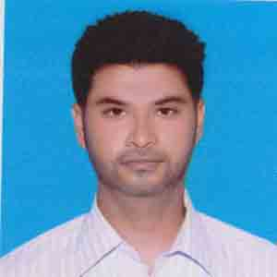
Md.Mijanur Rahaman
Cell Number: +8801916694586
Mail-bengir889911@gmail.com

Career Goal
To secure a position in profession where I can set out to exploit my creativity, versatile skills, dynamic characteristics and above all my educational and practical experiences to enlighten my career and enrich professional experiences to contribute in the welfare of my country.

Personal Details
Name : Md.Mijanur Rahaman
Fathers Name : Md. Shahaidul Islam
Mother’s Name : Mst. Tafuron Nesa
Date of birth : 25/06/1995
Place of birth : Jhenidah
Blood Group : A (+VE) Positive
Marital status : Unmarried
Sex : Male
Height : 5-7″
Weight : 65 Kg
Religion : Islam (Sunni)
Nationality : Bangladeshi (By birth)

Permanent Address
Village: Bhatoi, P. O.: Bhatoi Bazar,
P. S.: Soilkupa, District: Jhenidah.

Mailing Address Village: Bhatoi, P. O.: Bhatoi Bazar,
P. S.: Soilkupa, District: Jhenidah.

Educational Qualification

Bachelor Arts (BA)
2017
Govt. Rajandra College, Faridpur.
National University
Result: 2.65 (Out of 4)

Higher Secondary Certificate (HSC) in Humanities
2012
Bangabandhu Memorial College,
Result: GPA 3.30( out of 5.00)

Secondary School Certificate (SSC) in Business Studies
2010
Bhatoi Secondary School (Jessore Board)
Result: GPA 3.69 out of 5.00

Computer Education (Certified)
- Computer Office Application (MS Word, MS Excel, Power Point & Internet)

Specialty
- Affable and open
- Ability to manage things, and work with group
- Ability to convince people
- Good presentation skill
- Strong observation and motivation power
- Quick learning, decision taking within very short time & rapid implementation
- Wonderful communication ability from top to bottom level management system

Language
Bengali : Mother language
English : Writing, speaking & listening ability, good communication skill.
Working Experience:

- Name of Organisation: Anwar Cement Sheet Limited
Position : Executive Officer
Period : 08/11/20 continue

I, hereby, affirm to the apex of my comprehension and belief that this CV accurately describes my qualifications, experiences and me. I realize that any deliberate misstatement forwarded here in, may result me in disqualification or dismissal, if employed.

Reference

Md. Faruk Hossain Md. Abdur Razzak
Post: T.K Group Post: Opsonin
Position: S.O Position: M.P.O
Jhenaidah Dhaka.
Mobile: 01611-525657 Mobile: 01733-808088

Signature
............................... Date: .
(Md.Mijanur Rahaman

