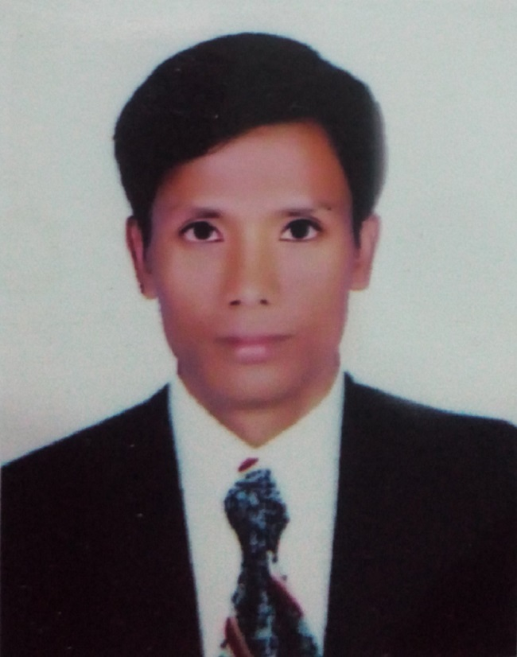
Resume
Of
Tapan Adhikary

Mobile: 01737892176
01822739653
Email: tapan1760@gmail.com
Career Objective:

To run responsible position where I can use my education, Interpersonal skills, creativity and all my learning experience in order to develop my career as well as to contribute in the welfare of the organization.

Career summary:

To obtain a challenging position as a Automobile Engineer where I can learn and contribute in positive ways. I am confident that if provided the opportunity to serve your organization, I will prove myself to be an important asset for your organization through my dedication, sincerity, and highest level of professionalism.

Academic Qualification:

Exam Title | Group | Institute | Board | Passing Year | Result
Diploma in Automobile Engineer | Automobile Technology | MAWTS Institute of technology | Bangladesh Technical Education Board (BTEB) | 2014 | 3.77
H.S.C | Science | Pirganj Gov’t College Thakurgoan | Dinajpur | 2009 | 2.80
S.S.C | Science | Kastor High School | Rajshahi | 2006 | 4.06

Training Summary:

Training Title | Topic | Institute | Location | Year | Duration
Industrial Attachment | Welding, Denting & Painting, Engine servicing etc. | MAWTS Institute of technology | 1/C-1/A Pallabi, Mirpur-12,  Dhaka- 1216 | 2013 | 20/01/13 -  05/04/13
Industrial Attachment | Engine system, Cooling System, Brake system, Electric system etc. | Power Craft workshop | 29, Monipuri Para, Sangsad Avenue Tejgoan, Dhaka | 2012 | 14/10/2012 -  15/01/2013

Personal Details :
Name : Tapan Adhikary
Father’s Name : Autul Chandra Adhikary
Mother’s Name : Punnima Rani
Date of Birth : 05 December, 1990
Gender : Male
Marital Status : Unmarried
Nationality : Bangladeshi
National Id No : 19909418234000152
Religion : Hindu
Permanent Address : Vill: Daulatpur, P.O: Kewutgoan, P.S: Pirgonj, Dist: Thakurgoan.

Experience : (01) The Metal (pvt.) Limited
Service In-Charge ( Junior Engineer )
Job duration 18th February, 2016 to Continue
(02) CP Bangladesh Co. Ltd.
Assistant officer
Job duration May 02, 2015 to 31th December, 2015

Responsibility : Planning and undertaking scheduled service and
maintenance. Supervising technical staff. Maintaining
stock book of tractor spare parts and equipment. Customer
satisfactory service in right time.

Computer Literacy : Office Application (MS Word, MS Excel, MS
Power Point, Internet Browsing & E- mail).

Language Proficiency : Good command in communicative.
Bangla (Reading , Writing & Speaking)
English (Reading Writing & Speaking)
References :

Name  Organization  Designation  Address  Mobile  Relation | :  :  :  :  :  : | Reference: 01 | Reference: 02
Name  Organization  Designation  Address  Mobile  Relation | :  :  :  :  :  : | Kumaresh Chandra Goon  Bangladesh Atomic Energy  Principal Scientific Officer  MAWTS Institute of Technology  01716917975  Professional | Md. Abdus Salam  Islamic University Of Technology (IUT)  Drafting Instructor  Board Bazar, Gazipur- 1704  01712531567  Professional


…………………..
Date : 16/01/2018 Sincerely Yours

