Mailing address:
House# 302, Shimrail (Moddhopara),
Kasba-3460, Brahmanbaria.
Contact Number
01734-608361
01679-111987
E-mail: badalahmed.sr@gmail.com

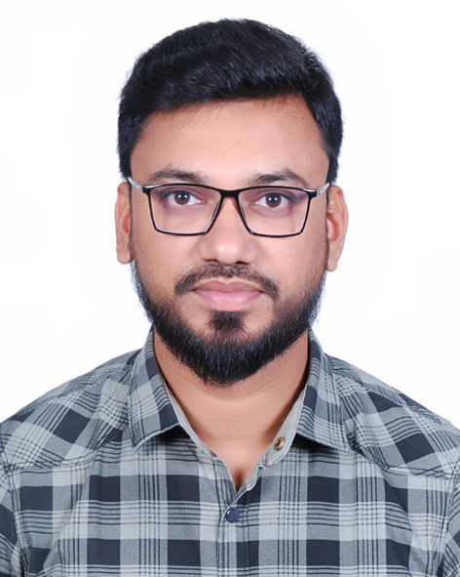

Photo
Curriculum Vitae
of
Md. Badal Miah

CAREER OBJECTIVES

To pursue a successful career in a well repute Organization that provides an excellent job environment for career growth of individuals and practices a professional performance culture where quality performance of talent and creativity is recognized and rewarded.

EDUCATIONAL QUALIFICATION

- MASTERS OF SOCIAL SCIENCE (Private)
Victoria Govt. College, Cumilla
Result : CGPA 2.53 (4.00)
Course Title : M.S.S, Passing Year :- 2015

- BACHELOR OF SOCIAL SCIENCE (PASS)
Chargachh N.I. Bhuiyan Degree College, Brahmanbaria
Result : 2nd Division (Marks- 666)
Course Title : B.S.S, Passing Year :- 2011

- HIGHER SECONDARY CERTIFICATE (H.S.C)
Brahmanbaria Govt. College
Result : GPA 2.60 (5.00)
Course Title : Science
Board : Cumilla, Passing Year :- 2008

- SECONDARY SCHOOL CERTIFICATE (S.S.C)
Shimrail High School
Result : GPA 3.94 (5.00)
Course Title : Science
Board : Cumilla, Passing Year:- 2006

STRENGTH AND ATTRIBUTES

- Honest, Punctual, Self-motivated and Result oriented.
- Hard working and capable to work under pressure.
- Comfortable to work either alone of in a team.
- Well organized, self-discipline, self starter.
- Leadership quality and interpersonal skills.

ADDITIONAL INFORMATION

COMPUTER PROFICIENCY | - MS Word, MS Excel, MS Power Point, Internet Browsing, E-mailing.
LANGUAGE SKILLS | - English :- Able to speak, read, write and understand  - Bengali :- Able to speak, read, write and understand

JOB EXPERIENCE

Company Name : Destiny 2000 Ltd
38, Kakrail Dhaka.
Designation : Silver Executive (Part Time)
Duration : 15th October 2010 to 31st December 2012 (2 Years)

2 Company Name : Everest Pharmaceuticals Ltd.
: 7, Hare Street Wari, Dhaka-1203.
Designation : Medical Promotion Officer (MPO)
Duration : 01st February, 2013 to 30th November, 2014 (2 years)

3. Company Name : Runner Motors Ltd.
138/1,Tejgaon Industrial Area, Dhaka-1208.
Designation : Jr. Executive, Direct Sales, VECV-Trucks
Duration : 1st January, 2015 to 30th July 2016 (1.5 Years)

4. Company Name : Rangs Motors Ltd.
117/A, L-4,Old Airport Road, Bijoy Sharani, Dhaka-1208.
Designation : Senior Executive, Direct Sales, VECV-Bus
Duration : 3st August, 2016 to Till Now.

PERSONAL DETAILS

Father’s Name : Md. Abu Nasir Miah
Mother’s Name : Rina Akter
Date of Birth : 5th November, 1990
Religion : Islam (Sunni)
Marital Status : Married
Gender : Male
Nationality : Bangladeshi (By Birth)
Blood Group : B+ (Positive)
Height : 5'-10"
National Id Number : 19901216382000142
Permanent Address : Village: Shimrail, P.O: Shimrail,
P.S: Kasba, Dist: Brahmanbaria.

REFERENCE

1. Md. Abdur Rahim
AGM, 4W(SML & Ravi)
Uttara Motors Ltd.
Cell : 01704169383

Md. Badal Miah

Date : ............................

