RESUME
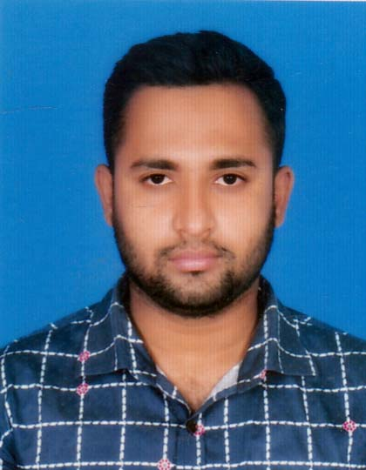
of
Mohammad Ali
C/O Md. Hossen Ali
Village : Tebaria, Post: Taherpur,
Upj : Puthia, Dist : Rajshahi
Cell : 01714719111

CAREER OBJECTIVE

To pursue a challenging career in a reputed organization where I can
utilize my personal expertise the ultimately leads to jobs satisfaction.

ACADEMIC QUALIFICATIONS

BACHELOR OF SOCIAL SCIENCE (BSS)

University : National University
Institution : Taherpur College, Rajshahi.
Examination Year : 2018
CGPA : 2.87

HIGHER SECONDARY CERTIFICATE (H.S.C)

Group : Humanities
Board : Rajshahi Board
Institution : Taherpur Degree College, Rajshahi.
Examination Year : 2013
GPA : 2.60

SECONDARY SCHOOL CERTIFICATE (S.S.C)

Group : Humanities
Board : Rajshahi Board
Institution : Borboria High School
Examination Year : 2011
GPA : 2.63

SKILL & ABILITIES :

  - Bengali and English.

COMPUTER LITERATURE :

- MS Word, MS Excel, MS Power Point, Internet Browsing and E-mail

EXPRIENCE:

- I have working Bashar Himagar Ltd, Bagmara, Rajshahi of Computer Operator 6 Years.
- I have working Aftab Automobiles Ltd (Under Real Motors), Bagmara, Rajshahi Assistant Manager Seles 5 Years.

PERSONAL GLIMPSES :

- Name : Mohmmad Ali
- Father’s Name : Md. Hossen Ali
- Mother’s Name : Most. Layly Begum
- Date of Birth : 13/07/1994
- Religion : Islam
- Sex : Male
- Nationality : Bangladeshi (by birth)
- Marital status : Unmarried
- Permanent Address : Vill: Tebaria, Post : Taherpur
Upj: Puthia, Dist: Rajshahi

- Present Address : Vill: Tebaria Post : Taherpur
Upj: Puthia, Dist: Rajshahi

I declare that, the Information Supplied by me on this Resume is true and correct in every particular.

Signature


(Mohmmad Ali)

Date:

