RESUME

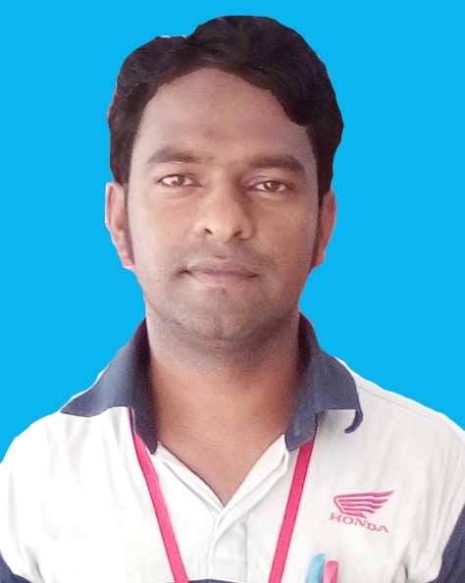
MD. MANIRUL ISLAM
B.B.S (Hons), MBS (Management)
National University
Joynabad, Kumarkhali, Kushtia.
Cell Phone: 01723-913452
E-mail: monir24.net@gmail.com

- CAREER OBJECTIVE:
To choose a career that involves challenges and opportunity for self development.
To develop career in a private organization and large working group.
To be hard working.
Willing to utilize conceptual and analytical skills to pursue a long term career in any organization to convey personal gratification.

- EDUCATION QUALIFICATION :
- M.B.S
Name of Institution : National University
Subject : Management.
Year of Passing : 2011
Session : 2010-2011
Result : 2nd Class

- B.B.S (Hons)
Name of Institution : National University
Subject : Management.
Year of Passing : 2012
Session : 2006-2007
Result : 2nd Class

- H.S.C (Higher Secondary Certificate).
Name of Institution : Kushtia Islamia College, Kushtia.
Group : Business Studies.
Board : Jessore.
Year of Passing : 2006
Session : 2004-2005
Result : GPA- 3.30

- S.S.C (Secondary School Certificate).
Name of Institution : Mohini Mohon Vidyapith, Kushtia.
Group : Science.
Board : Jessore.
Year of Passing : 2004
Session : 2002-2003
Result : GPA-3.81

- PERSONAL INFORMANITON:
Name : Md. Manirul Islam.
Nick Name : S.M.Monir.
Father’s Name : (Late) Md. Nurul Islam.
Mother’s Name : Ambia Begum.
Present Address : Vill: Joynabad, Post: Mohini Mills,
Union: Chapra, P.S: Kumarkhali,
Dist. Kushtia.
Permanent Address : Vill: Joynabad, Post: Mohini Mills,
Union: Chapra, P.S: Kumarkhali,
Dist. Kushtia.
Date of Birth : 16th October, 1989.
Place of Birth : Kushtia.
Nationality : Bangladeshi (by birth).
National ID No : 5017125589901.
Religion : Islam.
Blood Group : B (ve+) Positive.
Sex : Male.
Marital Status : Unmarried.
Height : 5´4″

- EXPERIENCE :
1. Position - Manager. (Spare Parts & Service)
Institute - Sardar Motors. Kushtia.
Duration - 3Years, (August, 2014-August, 2017)
Place - Kushtia.

RESPONSIBILITIES INCLUDE:
Preparing monthly report.
To monitor the activities of the staff.
 To maintain good relation with customers.
 Communications with various company.
 To work with strategy.

- COMPUTER KNOWLEDGE:
 Windows operating system, MS Word, MS Power Point, Ms Excel, Internet, Multimedia & E-mailing.

- LANGUAGE SKILLS :
 Bengali- Mother Tung.
 English- Fluently Reading, writing & Speaking.
 Arabic- Reading only.

- INTEREST & ACTIVITIES:
 Good communication and interpersonal skill able to work hard independently.
 Playing computer game.
 Traveling.
 Literacy Activities.

- OTHERS THAT DISCLOSE ME :
 Quick learning capability.
 Good management skill.
 Good team player.
 Dynamic.
 Self starter with strong organizational and interpersonal skill having a thirst to face new challenges.

- DECLARATION :
 According to my best knowledge information in this document is valid and accurate.

Md. Manirul Islam.

