RESUME OF
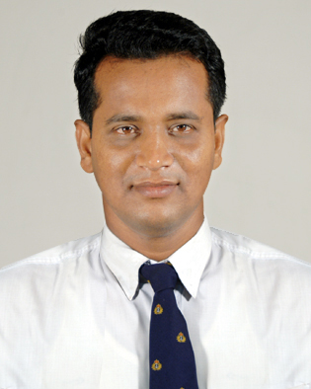
MOHAMMED ASHRAFUL ALAM
Cell :(+88) 01819 845538 (WhatsApp, Imo)
:(+88) 01670 660897 (WhatsApp, Imo)
e-mail : ovimail09@yahoo.com

Career Objective:

Looking for hard and challenging jobs where I will have the scope to utilize my potentiality, adaptability and skills to do something in olive and from where I will be able to enhance my knowledge.

Key Qualities:

- Good Academic Background steep learning curve
And strong analytical ability.
- Strong desire to achieve results, strong
responsibility taking attitude.
- Able to work under pressure.

Contact Address:

EMA Sourcing Ltd., 85- Nayanagar, Main Road, Harirampur,
Turag, Dhaka-1230.

Job Experience:

- 04 Year working Experience as a AGM (Administration, Commercial & Production) at EMA Sourcing Ltd., 85- Nayanagar, Turag, Dhaka-1230. ( From -2016 to Till).
- 05 Year working Experience as a Sr. Commercial Officer at Noman Group, 115-120 Motijheel, Dhaka-1000. ( From -2012 to 2016 ).
- 08 Years working Experience as a Section Officer (Administration) at National Univeristy, Gazipur-1704 ( From -2003 to 2012 ).
- 02 Years working Experience as Manager at Al Falah Development Ltd,
12/13 Motijheel, Dhaka-1000. ( From -2002 to 2003 )

Permanent Address:

Vill: Shaesta Nagar, P.O: Barkota - 3517,
P.S: Daudkandi, Dist: Comilla, Bangladesh.

Personal Information:
Name : Mohammed Ashraful Alam
Father’s Name : Mohammed Mobaruk Hossain
Mother’s Name : Majeda Begum
Date of Birth : 1st January 1974
Place of Birth : Comilla
Nationality : Bangladeshi (By birth)
Religion : Islam (Sunni)
Sex : Male
Marital Status : Married
Height : 5′-7″
Blood Group : A+

Computer/Other Skills:
- Certificate Course on Computer Application.
- General English Course from British Council.

Academic Profile:

- Name of Exam : M.Sc in Zoology
Institution : Jagannath University, Dhaka.
Result : 2nd Class
Year of Passing : 1998
University : National University

- Name of Exam : B.Sc.
Institution : Hasanpur Govt. S.N. College
Result : 2nd Class
Year of Passing : 1996
University : National University

- Name of Exam : H.S.C
Result : 1st Division
Group : Science
Institution : Dhaka City College
Year of Passing : 1992
Board : Dhaka

- Name of Exam : S.S.C
Result : 1st Division
Group : Science
Institution : Barkota High School
Year of Passing : 1990
Board : Comilla.
Language proficiency:

- English, Bengali as well working knowledge of Hindi.

Interest & Hobby:

- Traveling, Sports, Reading & Writing etc.
Declaration of Authenticity:

I do hereby declare that all information presented here is true to my knowledge. If required and applicable, this document can be submitted authentic papers.

Mohammed Ashraful Alam

