RESUME
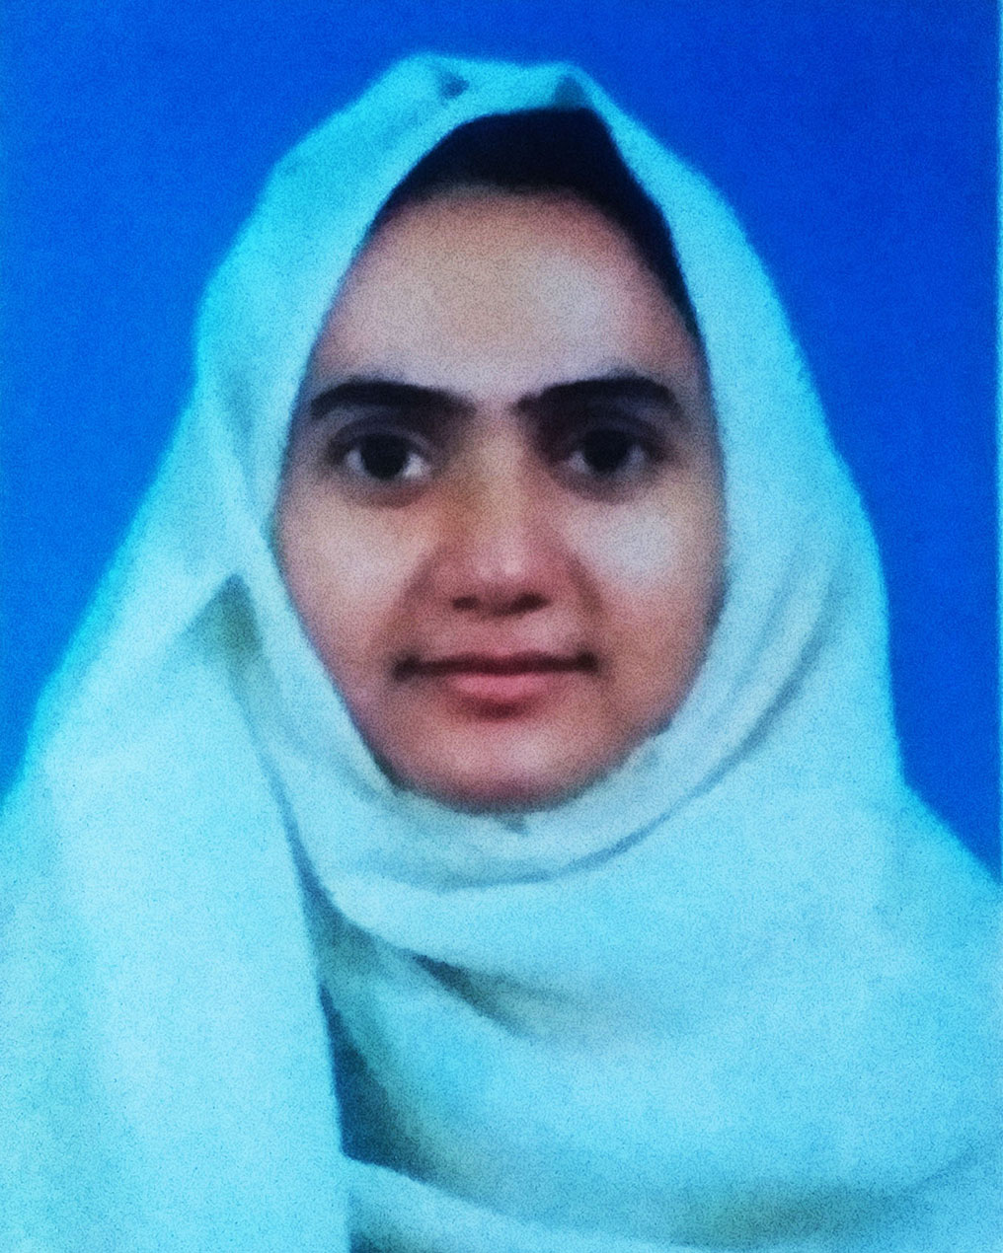

OF
Rabeya Akter

Mailing Address:  Rabeya Akter  891,Khan House  East Tafalbaria Farajir Hat  Mathbaria, Pirojpur |  | Contact Number:  Mobile: +8801715288438  E-mail: rabeyarumi09@gmail.com

CAREER OBJECTIVES

To pursue a highly rewarding career, seeking for a job in challenging and healthy work environment where I can utilize my skills and knowledge efficiently for organizational growth. To work hard with full determination and dedication to achieve organizational as well as personal goals.

EDUCATIONAL QUALIFICATION

Bachelor of Business Administration (BBA)

 Institution | : | Barishal Information Technology College (BITC)
Department | : | BBA
Duration | : | 4 years
Year of Passing | : | 2019
Major | : | Finance
Result | : | 2.75 (out of scale 4.00)

Higher Secondary Certificate (HSC)
 Institution | : | Shahadat Hossain College
Group | : | Business Studies
Year of Passing | : | 2015
Result | : | 3.30 (out of scale 5.00) Grade B
Board | : | Barishal

Secondary School Certificate (SSC)
 Institution | : | Nali Vim Chandra Secondary School
 Group | : | Business Studies
Year of Passing | : | 2004
Result | : | 3.31 (out of scale 5.00) Grade B (Without 4th sub.)
Board | : | Barishal

COMPUTER Skills

Application Software: Office Management.
Internet: Internet Browsing & Communication.
Also have an excellent typing speed in both English & Bengali

STRENGTH
- Communicative, friendly, positive thanking attitude & willing to serve dedicatedly
- Readiness to work with a stress worthy environment.
- Handle high pressure situation and deadlines.
- Sharp sense of social responsibility.
- Dynamic, extrovert, and resourceful.
- Research: 2016-2020 prepared research report in various business subjects in academic purpose.

LANGUAGE AND COMMUNICATION EFFICIENCY

Good command over reading, writing, listening and speaking in both English & Bengali.

EXPERIENCS
Research: 2016-2020 prepared research report in various business subjects in academic purpose.

PERSONAL DETAILS

Name | : | Rabeya Akter
Father’s Name | : | Md. Nurul Haq Khan
Mother’s Name | : | Jahanara Begum
Permanent Address | : | Village :East Tafalbaria Farajir Hat.  Post: Noli Charok Gasia.  P. S: Mathbaria.  Dis: Pirojpur
Date of Birth | : | 22th sep1995
Martial Status | : | Single
Sex | : | Female
Religion | : | Muslim
Nationality | : | Bangladeshi (by born)
Home District | : | Pirojpur
Height | : | 5 ft 3

Declaration of Authenticity

I declare hereby that all information I have presented so far are true to my knowledge. If required and where applicable, this document can be supported by authentic certificates papers.


Signature:………………………

