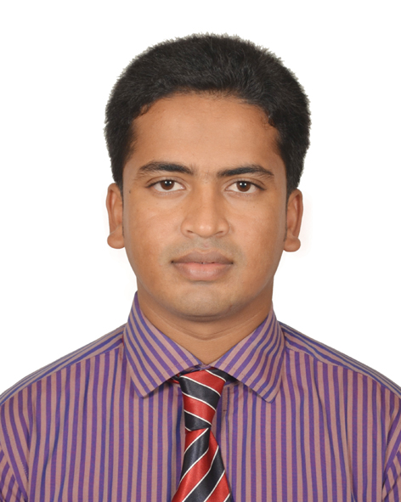
Resume
Of
Narottam Sarker

Mailing Address:
House-4, Lane-4, 6/A
Mirpur-6, Dhaka-1216.
Mobile: 01713621113
Email: eee.narottam@gmail.com

Career Objective:

Positively contribute to work in a challenging environment where analysis, creativity and hard working are the platform for excellence. I shall prove my strength if you would be give any opportunity.

Educational Qualification:

Bachelor of Science (B.sc) in Engineering
Institution : Uttara University.
Subject : Electrical and Electronic Engineering (EEE).
Result : CGPA-(3.10 out of 4.00).
Passing Year : 2018

Diploma in Engineering
Institution : Grassroots College of Technology.
Subject : Electrical.
Result : CGPA-(3.56 out of 4.00).
Passing Year : 2014
Board : Technical Education Board.

Secondary School Certificate (SSC)
Institution : Bedgram High School.
Subject : Science.
Result : GPA-(3.63 out of 5.00).
Passing Year : 2009
Board : Dhaka.

Aptitudes:

- Self-confident.
- Highly spirited.
- Proficiently motivated & ability to others.
- Ability to conveyance the people.

Personal Information:

- Name : Narottam Sarker.
- Father’s Name : Narayan Sarker.
- Mother’s Name : Rebha Rani Sarker.
- Date of Birth : 08 July 1993.
- Sex : Male.
- Marital status : Unmarried.
- Permanent address : Vill: Sarsakandi, P.O: Ujani, P.S: Muksudpur, Dist: Gopalganj.
- Religion : Hindu.
- Nationality : Bangladeshi.

Language Proficiency:

- Bengali: Speaking, listening, reading, writing excellent (mother tongue).
- English: Speaking, listening, reading, writing well (2nd language).

Computer Proficiency:

- Office Application : MS-Word, MS-Excel.
- Internet Explorer : E-mail operations, Internet Browsing etc.

[

Training and Award:

- 6 months training on Electrical Machine Maintenance (EMM) from Bangladesh Korea Technical Training Center (BKTTC).
- 6 Months Computer Trainining on Department of Social Service (DSS).
- 6 months training on Power Grid Company of Bangladesh Ltd. (PGCB).
- Excellency awards for PowerPoint presentation.
Experience:
I have been working in United Group (United Power Plant) as an Assistant Project
Engineer from 01-10-2018 to till now.
Reference:

Goutam Barai.
Upazila Nirbahi Officer (UNO), Anwara-Chittagong.
Mob: 01736489800

Declaration:

I hereby declare that the information given above is true to the best of my knowledge and belief. I hope my qualification will meet your requirement. I would appreciate if an opportunity his give to convince you of my merits and competence me.

Date:

…………………….
Narottam Sarker

