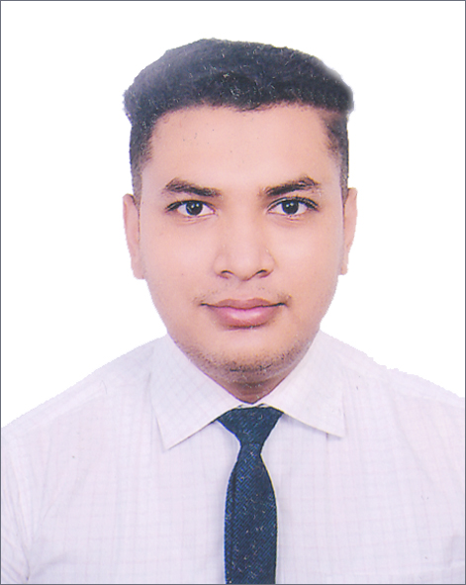
Resume
Of
MD. ABU AL ARAFAT
C/O. Md. Abu Hasan
Vill: Natun Bilshimla, P.O: G.P.O-6000,
P.S: Rajpara, Dist: Rajshahi
Mobile : 01767-901896
E-mail: mdabualarafat16@gmail.com

CAREER OBJECTIVE
Looking for a Challenging job where I will have the scope to utilize my Potentiality, adaptability and skill to do something innovate and from where I will be able to enhance my knowledge.
Experience:
1. Manager of Biology Plus (4 years)
2. Owner of Resturent (Petuk Khana)
3. Company: Sadika international (Wiping Rags)
Position: Marketing Manger
4. Internship: NCC Bank
EDUCATIONAL QUALIFICATION

Bachelor of Business Administration (B.B.A)
University : Varendra Univeristy
Faculty : Bachelor of Business Administration
Subject : Finance & Banking
Result : 2.97 (Out of 4.00)
HIGHER SECONDARY CERTIFICATE (H.S.C)
Institute : Rajshahi Govt. City College, Rajshahi
Subject : Business Studies
Exam Year : 2016
Result : 3.69 (Out of 5.00)
Board : Rajshahi
SECONDARY SCHOOL CERTIFICATE (S.S.C)
Institute : Seroil Govt. High School, Rajshahi
Subject : Science
Exam Year : 2014
Result : 4.69 (Out of 5.00)
Board : Rajshahi
LANGUAGE PROFICIENCY
Bangla (Spoken, Written, Reading and listing).
Excelent, Execelent, Execelent Execelent
Good Knowledge in English (Spoken, Written, Reading and listing).
Satesfactor, Satesfactor, Execelent Execelent
COMPUTER KNOWLEDGE
Knowledge on operating system : MS Word, MS Excel, Graphic Design, Survey (U.S.A), Amazon, MS Power Point.
PERSONAL INFORMATION

Name : Md. Abu Al Arafat
Father's Name : Md. Abu Hasan
Mother's Name : Mst. Merina Akter (Ripa)
Present Address : Vill: Natun Bilshimla, P.O: G.P.O-6000
P.S: Rajpara, Dist: Rajshahi.
Parmanent Address : Vill: Natun Bilshimla, P.O: G.P.O-6000
P.S: Rajpara, Dist: Rajshahi.
Date of Birth : 16-11-1999
Gender : Male
Religion : Islam
Nationality : Bangladeshi (by birth)
Blood Group : O (+)
Height : 5′-10′′
Marital Status : Unmarried
Contact No. : 01767-901896, 01720-951363

REFERENCE
Dr. Md. Moksed Ali
Private Secretary to Hon’ble Deputy Leader
(Deputy Secretary)
Bangladesh Parliament
Mobile:+88-01726509418
E-mail:moksedbd@yahoo.com
DECLARATION
I Declare that all the information included here true to my knowledge. If required and where applicable, this document can be supported by appropriate authentic certificates. Thanking you in anticipation.

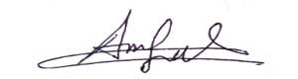

(Md. Abu Al Arafat)

Date : ..29 /08/2022

