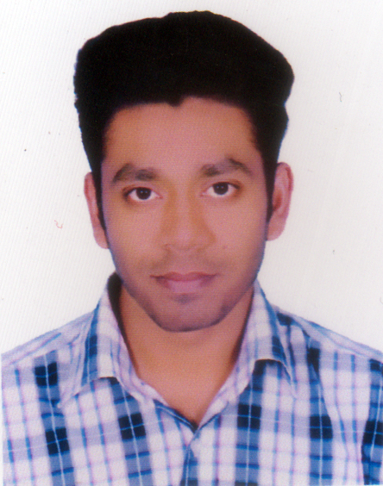
CURRICULUM VITAE
OF
Md. Rayhan Mahmud
Mahmudr996@gmail.com
Mailing Address:
235, South Kutubkhali,
South Jatrabari, Dhaka-1236

Cell Phone: 01836445186.

Objective:

- To work in an environment where there is an opportunity of self-assessment and self-improvement in both individual and group based work that will ultimately lead to the further development of the organization.

Personal Qualification:

- Ability to cope up with different situation.
- Very good temperament and like to take challenge.
- Co-operative & innovative.
- Good communication skill and ability to interact will with subordinate workforce.
- Can learn quickly to necessary details of work.
- Possess the necessary dynamism to achieve results.

Academic Attainment:

- Graduation Honrs (4 Years)
Institute : Dhaka college (Under DU)
Board : Dhaka.

Program : Bangla(4 year running).

- Higher Secondary Certificate

Institute : Govt. Kabi Nazrul College.
Board : Dhaka.
Group : Humanities.
Passing Year : 2014
Result : G.P.A : 3.30
- Secondary School Certificate

Institute : A.k School & College.
Board : Dhaka.
Group : Humanities.
Passing Year : 2012
Result : G.P.A : 4.13

Language Proficiency:

- English : Excellent reading, writing and listening ability.
- Bengali : Excellent reading, writing and listening ability.

Personal Details:

Father’s Name : Abdul Mannan.
Mother’s Name : Alaya Begum.
Permanent Addres : Abur Kandi, Motlob, Chadpur.
Date of Birth : 07.03.1997
Religion : Islam (Sunni)
Marital Status : Unmarried
Height : 5 feet 6 inch
Sex : Male.
Experiences
Work sells and marketing department at VIVO phone company from 06-12

2017 to till now

Declaration:

I am Md. Rayhan Mahmud here by certify that all the above-mentioned factors are true and are of my complete knowledge only.

Computer Literacy:

- Working knowledge of Office Program.
- Working knowledge of Internet.
- Working knowledge of Maintenance of PC.

Md. Rayhan Mahmud

