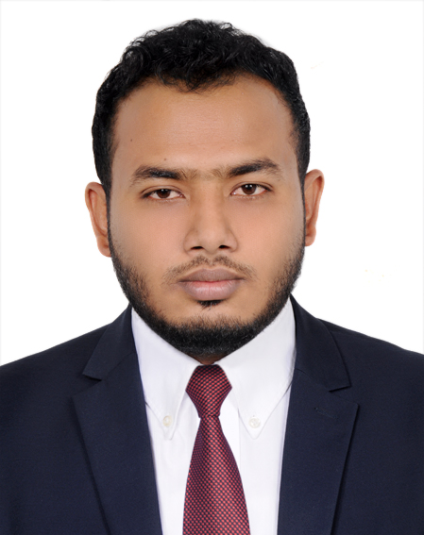
RESUME
OF
MD. IMRAN HOSSAIN
Cell: +88 01912955354, 01842955354
E-mail: imu.imran70@gmail.com
House: 07, Block-D, Road-1, Dhaka Uddan Housing, Mohammadpur, Dhaka-1207

Career objective:
To work in dynamic, modern and challenging environment to prove myself as a quick learner and highly energetic person where the creativity and the interest can be found to develop the Skill as well as a successful career. Secure a responsible career opportunity to fully utilize my training and skills while making a significant contribution to the success of the company.

Experience:
Company: RANCON GROUP.
Designation: Territory Sales Manager
Concern: RANGS INDUSTRIES LTD.
Starting: 15-10-2017 to till now
Duties/Responsibilities:
1. Plan and split to field force given monthly sales target and work accordingly.
2. Reporting to (ASM, DSM) sir daily, weekly & monthly basis.
3. Appoint potential Distributor and handle according to company norms.
4. Properly monitoring filed force & utilize maximum of POSM materials.
5. Prepared monthly distributors sales analysis on the basis of pack.
6. Properly monitoring of Primary & Secondary sales and calculate distributor ROI.
Company: BASHUNDHARA GROUP.
Designation: Territory Sales In-Charge
Starting: 07-08-2015 to 12-10-17
Duties/Responsibilities:
1. Sales Plan according to given Target value and volume.
2. Develop a unique sales function focusing on the market need.
3. Primary Sales and Secondary Sales Planning.
4. Sales Monitoring.
5. Sales trend analysis and making decision based on that.
6. Distribution Management  through review and business meeting.
7. Develop and growth opportunity by developing sales programs.

Company: FAIR GROUP.
Concern: Fair distribution Ltd.
Designation: Territory Sales Officer
Duties/Responsibilities:
Starting: 01-02-2011 to 07-06-2015
1. Planning and forecasting given monthly sales target and focus on that.
2. Accusation a unique sales function focusing on the market need.
3. Monitoring sales executive focus on monthly target.
4. Primary Sales and Secondary Sales Planning.

Educational qualification:

Masters in Professional Marketing (M.P.M)
Institute : University of Dhaka
Subject : Marketing
Result : Appeared
Passing : 2019

Masters of Business Administration (M.B.A)
Institute : National University
Subject : Accounting
Result : 2.84
Passing : 2015

Bachelor of Business Administration (B.B.A)
Institute : National University
Subject : Accounting
Result : 2.89
Passing : 2014

Higher Secondary Certificate (HSC)
Institute : Chuadanga Govt. College
Board : Jessore
Subject : Business Studies
Result : GPA- 4.60
Passing year : 2010

Secondary School Certificate (SSC)
Institute : Chuadanga Academy High School.
Board : Jessore
Subject : Business Studies
Result : GPA-4.69
Passing year : 2008

Computer Literacy:
Package : MS Office [MS Word, MS Excel, MS Power Point & MS Excel] Good typing speed both
English & Bengali.
: Internet Browsing, E-mail & Communication.

Competencies
Honesty, Hard working, Dedication, Posses Leadership Quality
Language Proficiency:
Bengali is the native language
Good command in reading, writing and speaking in English.
Training: Effective Leadership and How to Handle Potential Distributor
Speaker: Md. Razib Ahmed

Personal information:
Name : Md. Imran Hossain
Fathers Name : Ekramul Hoque
Mothers Name : Sabia Khatun
Permanent Address : vill: Luxmepur, P.O:Gopalpur P.S: Damurhuda, District:-Chuadanga
Current Address : House: 07, Block-D, Road-01, Dhaka Uddan Housing, Mohammadpur,DHAKA-1207
Date of a Birth : 16/08/1992
Marital Status : married
Sex : Male
Religion : Islam (Sunni)
Weight & Height : 5and 7 [78 kg]
Blood : A+

Reference :
Md.Rafiqul Islam Md. Enamul Haque
Business Development Manager Area Sales Manager
Bombay Sweets & Co. Ltd. Emami Bangladesh Ltd.
Bangladesh Cell: 01964-685013
Cell: 01717-545284



Signature & Date
Md. Imran Hossain

