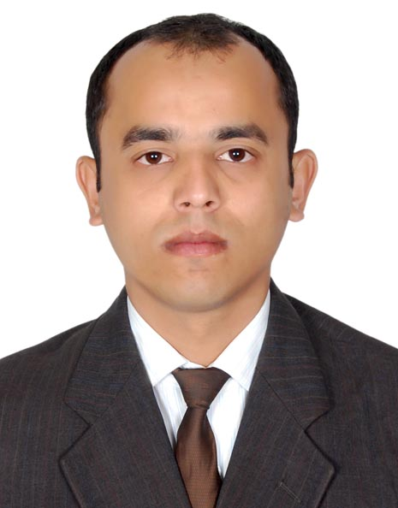
Rajesh Kumer Datta
Contact: +88018 4129 9082, +88017 3009 3285
Email: rajesh.datta@hotmail.com || Linked In URL
Location: Narayanganj, Dhaka, Bangladesh

CAREER SUMMARY:
To utilize skills and qualifications for achieving the company’s goals as well as to make an outstanding professional in corporate sector and Possessing 6 years 10 months progressive experience about sales, distribution and trade marketing as well as capable in training and motivating sales representative to provide a successful customer service. Areas of skill include:
Communication, Facilitation, Trainer, Business planning & development, Decision making, Execution, Analytical, Problem solving, Negotiation, Time management and Interpersonal.

PROFESSIONAL INFORMATIONS:
I. Bangladesh Edible Oil Limited (A subsidiary of Adani Wilmar Pte. Limited), Bangladesh.
Territory Manager, September 2015 to presents(4 years 4 months), Dhaka South Region- Narayanganj, Reporting to- Md. Golam Mostafa, Regional Sales Manager.

Key Contributions:
- Sales growth 1% in 2019 whereas national growth 2%, Generating average business per month 180 MT and in value per month BDT 19 million (Approx) over 8 distributors.
- Monitoring 93 routes by 16 Sales Representatives, Advancing distribution by outlet expansion 230 outlets. Total coverage 4789 outlets over 47 field forces and developing alternative business channel like restaurants and chemist outlets also.
- Expanding business by establishing Rupchanda Nazirshail Rice in 7 towns & Replacement 2 distributors in Demra town & Fatullah town.
- Coordinating & developing consumer awareness activities across the territory like Meizan pouch activation, RCS pouch activation and customer engagement activities also.

- Worked 3 years 8 months in Munshiganj territory & attained business in value 16.1 million from 8.3 million by 7 town through 3047 outlets and 32 field forces. Appointed 2 distributors in 2017, 3 distributors in 2016 by area demarcation, Recruited 7 Sales Representatives for RTM development and Monitored 64 routes by 11 Sales Representatives. Expanded business by establishing 4 brands like King’s Sunflower Oil, Fortune Basmati Rice, Veola Soya bean Oil & Rupchanda Minicate Rice in 7 towns.

II. Pacific Bangladesh Telecom Limited (A subsidiary of Pacific Motors Limited & Singapore Telecommunications Limited), Bangladesh.
Territory Business Manager, March 2014 to August 2015(1 year 5 months), Dhaka South Region- Ramna, Reported to- A.B.M. Mannaf Parag, Area Business Manager.

Key Contributions:
- Appointed 2 distributors in 2015 for Ramna & Mohammadpur territory and additionally coordinated Mohammadpur territory for 4 months.
- Conducted spot activation & campaign for user acquisition & development as well as taken initiatives to increased business- Shared Valentine day gifts & T20 World cup gifts with best 200 retailers and arranged gift for Sales Representative on KPI of sales.
- Shared guidance & knowledge with 2 Territory Business Manager during their induction period & taken responsibilities as an acting Area Business Manager for 18 days of Dhaka South Metro.

III. Abdul Monem Limited (Authorized bottler of Coca-Cola Company), Bangladesh.
Area Sales Officer, February 2013 to March 2014(1 year 1 month), Chittagong Region- Agrabad, Reported to- Syed Md. Salim, Regional Sales Manager.

Key Contributions:
- Sales grown 21% with RGB contribution 24% in 2013 over 2012 by outlet coverage & expansion, increase productivity, display & merchandising, ensure & execute trade scheme & activities, product quality & customer service over 2 distributors.
- Taken initiatives to increase coverage like create Coke day (every Saturday), visit community centre & HoReCa (every Thursday), inject Ice Box in tea stall to increased RGB coverage & modified trade activity to increase distribution.
- Supervised sales generate assets & logistics, created exclusive outlet, outlet branding, modern trade & institutional business over 6 PSR & coordinated event & activation-CITF 2014, IWSME Trade Fair 2013.
- Capabilities developed of 16 field forces by guidance & training to increase efficiency.
- Collected company outstanding from credit distributors & transformed into cash business.

TRAINING INFORMATIONS:
- Attended training on ‘Creative & Effective Selling Techniques’ in 2017 conducted by Razib Ahamed, Trainer & Sales Development Specialist, Bangladesh.
- Attended training on ‘Rise & Shine Motivational Session’ in 2016 conducted by Akash Gautam, Motivational Speaker and Corporate trainer, India.
- Attended training on ‘Basic Sales Techniques & Product Knowledge’ in 2016 conducted by Ahmmed Ali, Bangladesh Edible Oil Ltd., Bangladesh.
- Attended training on ‘Sales & Distribution Management’ in 2013 conducted by Debashish Dev, Coca-Cola Far East Ltd. & Pratap Rawal, Abdul Monem Ltd., Bangladesh.

INTERNSHIP INFORMATIONS:
Transcom Beverage Ltd. (Franchise of PepsiCo), Bangladesh.
- Internship (MBA), March 2012 to April 2012 (1.5 months), Head Office.
- Internship (BBA), July 2010 to August 2010 (1.5 months), Head Office.
Learning’s- Monitored brand activities & communication, Trade activities, Followed sales & distribution operation.

SCHOLASTIC INFORMATIONS:
- Masters of Business Administration in Marketing (2012),
CGPA: 3.09 out of 4.00; Daffodil International University, Dhaka, Bangladesh.
- Bachelors of Business Administration in Marketing (2010),
CGPA: 2.78 out of 4.00; Daffodil International University, Dhaka, Bangladesh.
- Higher Secondary Certificate in Business Studies (2006),
GPA: 2.80 out of 5.00; Chandpur Govt. College, Chandpur, Bangladesh.
- Secondary School Certificate in Business Studies (2004),
GPA: 3.19 out of 5.00; Chandpur Hasan Ali Govt. High School, Chandpur, Bangladesh.

PERSONAL INFORMATION:
Permanent Address : Villa. & P.O.: Durgapur, P.S. & Upazila: Comilla Adarsha Sadar, Dist.: Comilla- 3500, Bangladesh
Date of Birth: September 1st, 1989
Blood Group: B (+) ve
National ID Number & Nationality: 1916794259353 & Bangladeshi
Marital status & Religion: Married & Hindu (Sonatan)

