RESUME OF
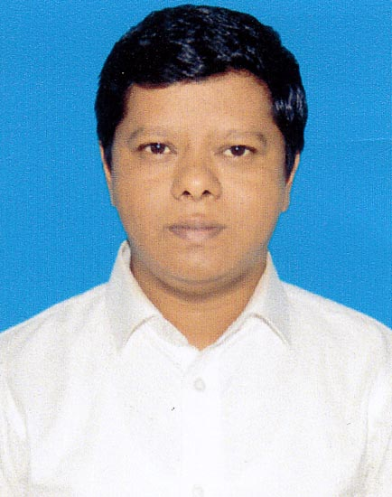
A.B.M. Towhidul Islam

Contact: House No # 55, (2nd Floor),
Road No # 12, Sector # 14,
Uttara, Dhaka
Cell: 01911212356
E-mail: towhid120@yahoo.com

CAREER OBJECTIVE

To work in a challenging environment where I can constantly enhance my knowledge, skills and harness my potential up to the optimum level and to become a valuable performer for the organization.

KEY STRENGTH

- To work in challenging environment.
- Capacity to work in a team with creative ideas.
- Quick learning aptitude.
- Stress tolerance/pleasure management capacity.
- High adaptability to changing solutions and environment.
- Self-initiatives to problem solving.
- Effective interpersonal and social communication skill.
- Leadership skill.
- Responsible for duties.

PROFESSIONAL TRAINING

- Professional Selling Skills.
- Effective Customer Service for Excellency
- Authorized Representative Program By DSE
- Fundamental Analysis Program on Securities
- Technical Analysis Program on Securities
- Internship in Uttara Bank, Kawran Bazar Branch

SOCIAL ACTIVITIES

- Foundation member of Friends Commerce Society. (Secretary 2004-2005, President 2005-2006).
- Foundation member of Firoza Kollan Somity (a family relationship Organization). Secretary 2002-Contanue.

COMPUTER LITERACY

 Office Program  Internet Operation  Software  Windows  Data entry

LANGUAGE

Bengali – Mother tongue
English – Well versed in both written and spoken English
EMPLOYMENT HISTORY

Organization : Reckitt Benckiser Bangladesh Ltd.
Designation : Territory Sales Manager
Working duration : From March 2014 to Continue
Responsibilities :
Main Duties:
- To plan and achieve the IMS through: Distribution and Productivity, Coverage Increase, Visibility and Merchandising.
- To train and provide coaching for distributor team.
- Distributor Management
- Ensure Customer Service, Administration & Coordination.
- Monitoring of the house and market.

Daily Duties:
- Secondary Sales/IMS Report, Update daily IMS Report & KPI Sheet.
- Monitor PJP adherence and section drop.
- Update New Product Development/ Existing Product Development.
- Market visit with specific objective and PJP
- Point of Sales Materials (POSM) utilization plan and implementation.
- Stock check and warehouse management and report to line manager.
- Check Order vs Delivery gap

Weekly Duties:
- Achievement against planned IMS & Productivity KPI.
- Plan for balance target.
- Re-enforce targets to DSR & Supervisor.
- Scheme & Promotional SKU update.
- Market visit with CM to check and implementation.

Monthly Duties:
- Last month performance review and update all KPI files.
- Monthly incentive target cascade down to DBSRs.
- CM’s monthly action plan.
- Prepare Permanent Journey Plan (PJP).
- Send Competitor’s activities.

Organization : Fun1 Communication
Designation : Assistant Manager (Event Management)
Working duration : From Jun 2010 to March 2014
Responsibilities :
- Researching markets to identify opportunities for events;
- Liaising with clients to ascertain their precise event requirements;
- Producing detailed proposals for events (e.g. timelines, venues, suppliers, legal obligations, staffing and budgets);
- Agreeing to and managing a budget;
- Securing and booking a suitable venue or location;
- Coordinating venue management, caterers, stand designers, contractors and equipment hire;
- Identifying and securing speakers or special guests;
- Coordinating staffing requirements and staff briefings;
- Selling sponsorship/stand/exhibition space to potential exhibitors/partners.
- Providing leadership, motivation, direction and support to my team.
- Communicating, maintaining and developing client relationships.
ACADEMIC QUALIFICATION

Masters of Business Administration (M.B.A)
Year of Passing : 2010
Result : 2.75 (Out of 4)
Major : Finance
University : Independent University of Bangladesh

Bachelor of Business Administration (B.B.A)
Year of Passing : 2007
Result : 2.81 (Out of 4)
Major : Finance
University : City University

Higher Secondary School Certificate (H.S.C)
Year of Passing : 2001
Group : Business Studies
Result : 1st Division
Board : Dhaka
Institution : Dhaka Commerce College

Secondary School Certificate (S.S.C)
Year of Passing : 1999
Group : Business Studies
Result : 1st Division
Board : Chittagong

Institution : Pahartoly Railway Govt. High School, Chittagong

Expected Salary

100,000/- (One Lac Taka)

PERSONAL INFORMATION

Name : A.B.M. Towhidul Islam
Father’s name : Mohammed Tajul Islam
Mother’s name : Syeda Najmun Nahar
Permanent Address : Vill -West Laxmipur, PO-Dalal Bazar, PS-Laxmipur. Chittagong
Nationality : Bangladeshi
Marital status : Married
Religion : Islam
Date of birth : 1 January 1983
Height : 5 feet 5 inch
Blood group : B (+)

REFERENCE

Syed Jafor Ahmad  Managing Director & CEO  Fun1 Communication  Voice :01823 063 773  E-mail : sj_ahamad@funonebd.com | Hasan Al Mahmud  Regional Sales Manager  Reckitt Benckiser Bangladesh Ltd  Voice : 01777759010  E-mail : nasah100@yahoo.com

