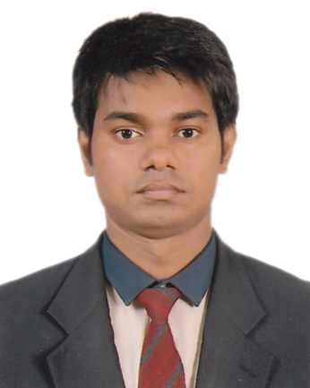 **Curriculum vitae**

**Of**

**Barshon kumar sarkar**

Contact No: 01737-385557

E-mail: [bksarkar10@gmail.com](mailto:bksarkar10@gmail.com)

**Career objective:**

To obtain a responsible executive position in a well reputed organization, that offer a modern working environment, ample and arrangement for profession development.

**Education:**

**Bachelor of Business Administration (B.B.A)**

Name of Institute : Institute of Science Tread and Technology (I.S.T.T) University : National University, gazipur

Board : Dhaka

Major : Marketing

Result : 2.68

Passing Year : 2012

**Higher Secondary Certificate (H.S.C)**

Name of Institute : Amla Gov’t college, Kushtia Board : Jessore Group : Business Studies Result : 3.10 Passing Year : 2007

**Higher Secondary Certificate (S.S.C)**

Name of Institute : Amlasadarpur Boys High School Board : Jessore Group : Science Result : 3.25 Passing Year : 2005

**Language Proficiency:**

Writing and speaking ability both in Bengali, English and Hindi speaking.

**Computer skill:**

Computer office program-MS Word, MS Excel, Power Point, Internet Browsing and E-mailing

**Other skill:**

1. I have got a prize at school level writing essay competition in 1999.
2. I have got a testimonial for attending as a volunteer of EPI programming in 2002.

**Interest:**

Music, Sport, Reading, Fashion, Modeling etc

**Personal Information:**

Father’s name : Sontosh Kumar Sarkar Mother’s name : Bakul Rani Date of Birth : 10-10-1989 Permanent Address : Vill – Sadarpur, P.O – Amla Sadarpur

P,S – Mirpur,Dist – Kushtia.

Present Address : 70/1 (4th floor), east rajabazar, farmget, Dhaka-1215

Religion : Hindu (Sunaton) Marital Status : Single Blood group : O+ (ve) Height : 6ft. Nationality : Bangladeshi by birth. Sex : Male

**Refarences :**

**Md. Ashraful haque**

Professor in English (Kushtia gov’t college)

Kushtia.

Mobile No: 01712-678948.

**Mahendra Nath Nag (Gopal)**

Manager (Creative Design)

REVE Systems Ltd

Kha-199/2, Maddhya Badda Dhaka 1212,

E-mail : gopal@revesoft.com

TelPhone No : 88029897111 (office), Fax : 88029897411

Mobile No : 01847-214958.

Date : Signature : ………………………………