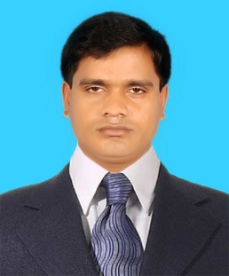Bijan Chandra Mazumder

Chandra, Kaliakair, Gazipur

[email-bijanmazumder435@gmail.com](mailto:email-bijanmazumder435@gmail.com%20)

Cell Contact: 01738-067435, 01969018160



**Career Objectives**

To lead & work in a dynamic position which will provide and develop my skill and qualifications to take the challenge of the day. I can implement my technical knowledge in the field of Industrial sector in the country especially in HR.



**Work Experience**

**Skills**

Being conversant in

Several computers

Languages such as MS

Word, MS Excel

Internet

Browsing Etc.

Awards

1. Labor Law .An

overview of

Bangladesh Labor

Law.   (BIMS).

2. Labor law & Rules

Grievance Handling,

Disciplinary Procedure,

Safety &Participation Committee Formation& Handling

Bangladesh Admin HR, Compliance &Welfare Society (BAHCWS)

3. Labor law

amended 2018 & PC and safety committee.

Bangladesh Admin HR, Compliance &Welfare Society (BAHCWS)

**Niagara Textiles Limited,** Chandra Circle,Gazipur, Dhaka, Bangladesh *Officer/ HRD*

August - 2018 - PRESENT

Responsibilities:

1. Update employee Personal File.   
2. To Prepare salary sheet.  
3. Monitoring employee performance.  
4. Prepare Job description for new employee  
6. Prepare job ID card for new employee  
7. Prepare final settlement.  
8. To motivate new employee about company s working environment  
9.To update increment break down into the service Record.  
10. To maintain hiring procedure.   
11. To assist recruitment process   
12. To assists on selection process   
13. To prepare Final Settlement for resign worker Completion of new recruited employees

14. Medical Fitness form with age verification by MBBS

Doctor.

*Masters of Business Administration (MBA)*



**Education**

**LANGUAGES**

* Bangla -Fluency Skill High
* English -Fluency Skill High

Institute : Daffodil International University

Passing Year : 2018

Result : 3.43

*Masters of Arts (M.A)*

Institute : Govt. Bangla Collage

Board : National University

Passing Year : 2012

Result : 2nd Class

**Bachelor of Arts (B.A)**

Institute : Bhandaria Govt. Collage.

Board : National University

Passing Year : 2010

Result : 2nd Class

**Higher Secondary School Certificate** **( H.S.C)**

Institute : Amanullah Mohabiddaloy

Board : Barisal

Passing Year : 2006

Result : CGPA 3.10(out of 5)

**School Secondary Certificate**: **(S.S.C)**

Institute : Nayakhali Mativanga High School

Board : Barisal

Passing Year : 2004

Result : CGPA 3.00 (Out of 5)

*Post Graduated Diploma in Human Resource Management (PGDHRM)*

Bangladesh Institute of Management Studies

(BIMS), Dhaka, Bangladesh-

Institute : BIMS

Passing Year : 2017

Result : Pass



**Training**

|  |  |  |  |  |  |  |
| --- | --- | --- | --- | --- | --- | --- |
| **Training Title** | **Topic** | **Institute** | **Country** | **Location** | **Year** | **Duration** |
| Labour Law | An overview of Bangladesh Labour Law. | Bangladesh Instute of Business Management (BIMS) | Bangladesh | Dhaka | 2018 | One Days |
| Labour Law  &  Rules | Grievance Handling, Disciplinary Procedure,  Safety &Participation Committee Formation& Handling | Bangladesh Admin HR,Compliance &Welfare Socity (BAHCWS) | Bangladesh | Dhaka | 2018 | One Day |
| Labour Law  &  Rules | Labour law amedend 2018 & PC and safety committee. | Bangladesh Admin HR,Compliance &Welfare Socity (BAHCWS) | Bangladesh | Dhaka | 2018 | One Day |



**Personal Details**

Full Name : **Bijan Chandra Mazumder**

Father Name : Late.Monimohon Mazumder

Mother Name : Aruna Rani

Permanent Address : Vill: PatlaKhali P.O: Nayakhali

P.S: Bhandaria Dist: pirojpur

Present Address : Chandra, Kaliakair, Gazipur.

Date of Birth : 30-06-1988

Sex : Male

Weight :75 Kgs

Height : 5.6 feet

Blood Group : B+ (Positive)

Nationality : Bangladeshi

Marital Status : Married

Religion : Hindu

|  |
| --- |
| **Reference: 01** |
| Name : Md Touhudul islam |
| Organization : Aman Group |
| Designation: GM (HR & Admin) |
| Address : Valuka |
| Phone (Off.) |
| Phone (Res.) |
| Mobile :01713756118 |
| Relation: Professional |

|  |
| --- |
| **Reference: 02** |
| Name : Md. Abu Taher |
| Organization : FCI BD Ltd |
| Designation: Manager HRM |
| Address : EPZ Savar Dhaka |
| Phone (Off.) |
| Phone (Res.) |
| Mobile :01711461451 |
| Relation: Professional |

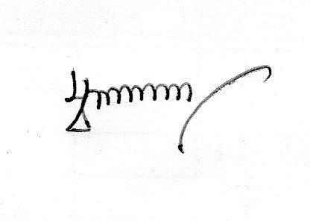Bijan Chandra Mazumder Date: 13.01.2020

Signature