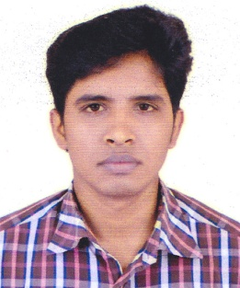**Resume**

**of**

**MD. SAIFUL ISLAM KABIR**

**Present Address:**

Room # 105, Eleyes Hall, Dhaka College, Dhaka

Mobile : 01712663475, E-mail : [saifulkabir712@gmail.com](mailto:saifulkabir712@gmail.com)

**Career Objective**

Intended to build up career in the highly potential institution and work in the challenging and competitive environment where higher degree of responsibility, sense of duty, commitment to job, proper skill, diligence are required to achieve organization’s desired goal along with personal career growth.

**Academic Profile**

**Fazil Pass**

Name of Institution **:** Tala Fazil Madrasha

University : Islamic Arabic University

Passing year **:** 2018

Result : CGPA-4.25

**Alim**

Name of Institution **:** Tala Fazil Madrasha

Group **:** General

Result **:** GPA 5.00 (Out of 5.00)

Year of passing **:** 2015

Board **:** Bangladesh Madrasha Board

**Dakhil**

Name of Institution **:** Tala Fazil Madrasha

Group **:** General

Result **:** GPA 4.88 (Out of 5.00)

Year of passing **:** 2013

Board **:** Madrasha Board

**Computer Skills**

* Modern Office Management & Computer Application
* Efficiency in MS Office (MS Word, Excel and PowerPoint),
* Internet Browsing

**Language Skills**

* Bengali : Excellent Command over reading writing & speaking
* English : Good Command over reading writing & Speaking

**Personal Strengths**

* Industrious, Curious, ambitious, amusing, and decent
* Excellent communication capability
* Motivating, leading & convincing power
* Ability to work under stress.
* Ability to work independently & with group

**Interest**

* Books & Magazines : Books Magazines Financial Journal & News

Paper

* + Entertainment Watching Movies, Cricket, Tours & Travels

**Personal Profile**

Name : **Md. Saiful Islam Kabir**

Date of Birth : 22th September, 1998

Father’s name : Md. Sirajul Islam

Mother’s name : Salma Khatun

Permanent Address : Village: Sirasuni, P.O: Sirasuni

P.S: Tala, District: Satkhira

Nationality : Bangladeshi by birth

Religion : Muslim

Marital Status : Single

Blood Group : B+

Sex : Male

**Declaration**

I hereby declare that the above mentioned statements are expressed my truthfulness and correctness.

..........…………………………

**MD. SAIFUL ISLAM KABIR**

Date