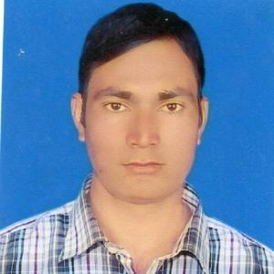 ***RESUME***

***OF***

***MD. Monjurul ismam***

Mailing Address : monjurulcare@gmail.com

Village : Hasimpur, P.O : goyaldihi -5240,

P.S : khansama, Dist : Dinajpur.

Mobile: +8801740207614

**Career Objective**

Searching for a challenging position in any private organization to utilize my skills, education and experience to meet organization nets and fulfill their demands.

**Personal Details**

Father’s Name : Md. Azizar rahman

Mother’s Name : Mossa. Khotakja Begum

Present Address : Village :hasimpur, P.O : goyaldihi-5240

P.S : khkhansama, Dist : Dinajpur.

Permanent Address : Village : hasimpur, P.O : goyaldihi -5240

P.S : khansama, Dist : Dinajpur.

Date & Place of birth : 25 February 1993, Dinajpur.

Natinality : Bangladeshi (By birth)

Religion : Islam.

Sex : Male.

Marital Status : Unmarried.

Height : 5.7”

Blood Group : O- (negetive).

National ID NO : 19932716079000042.

**Educational Qualification :**

**Bachelor of business administration (B.B.A Honors)**

Institute : Nilphamari govt college, Dinajpur.

Subject : Manegement

Result : G.P.A-2.83 (out of 4)

Passing Year : 2015

University : National University

**Higher Secondary Certificate (H.S.C)**

Institute : Alokdihi ideal college , Dinajpur.

Group : business study group.

Result : G.P.A-2.90 (out of 5)

Passing Year : 2011

Board : Dinajpur.

**Secondary School Certificate (S.S.C)**

Institute : Chhatiangorh madhamik bidhalay, Dinajpur.

Group : Science.

Result : G.P.A-3.81 (out of 5)

Passing Year : 2009

Board : Dinajpur.

**Language Skill**

Bengali Mother Tongue

English Good Command in reading, writing, speaking,

**Computer Skill**

Environment Windows 98, 2000, Windows7

Communication Internet, E-Mail

**Strengths**

* Hard-working
* Communicative and friendly
* Enthusiastic
* Self motivated
* Industrious
* Punctual
* Dynamic & Creative thinker
* A team player
* Analytical mind
* Adoptive to new technology and a quick learner
* Organized Mass People of there right

**Extra Curriculum Activities**

* Youth development Program
* Teaching and Social Worker

**I hereby declare myself, all the statements CV are authentic and correct to the best of my concern.**

Md.Monjurul ismam

16/09/2020

Signature and date