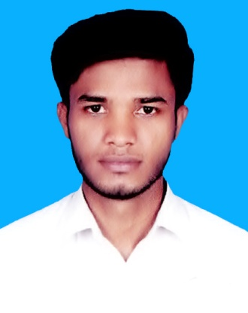**Resume Of**

**Md. Ruhul Amin**

***Mailing Address:***

Vill: Degerchala, P.O: National University

P.S: Gazipur Sadar, Dist: Gazipur.

Cell: **01991-326926**

**Objective**

To build up career in the field where my competency can be developed. To choose a career that involves challenges and opportunity for self development. To develop career in a private organization and large working group. To be hard working. Willing to utilize conceptual and analytical skills to pursue a long term career in any organization to convey personal gratification.

**Educational Qualification**

**Higher Secondary Certificate (H.S.C)**

Institution : Bhawal Badre Alam Govt. College

Board : Dhaka

Group : Business Studies

Result : 3.33

Passing year : 2018

**Secondary School Certificate (S.S.C)**

Institution : Shorifpur Giash Khan High

Board : Dhaka

Group : Business Studies

Result : 4.44

Passing year : 2016

**Job Experience**

**Organization : Angina Mega Mall.** **Organization : Pran Rfl Group**

Location : Uttara. Location : Uttara

Position : Sales Executive Position : Brand Promotor

Duration : 06 Months. Duration : 01 Year.

**Computer Skills**

* Microsoft Office Application
* Internet Browsing, E-mail.

**Language Proficiency**

Bengali- Mother Tongue

English- High (Reading, Writing, Listening & Speaking)

**Strengths**

* Like to face new people and Environment.
* Hard working habit, self driven.
* Strong communication and inter personal skill.

**Personal Details**

**Name : Md. Ruhul Amin**

Father’s Name : Abdur Razzak

Mother’s Name : Jamena Begum

Permanent Address : Vill: Tarati, Post: Maigbag,

P.S: Ishwarganj, Dist: Mymensingh.

Present Address : Vill: Degerchala, Post: National University

P.S: Gazipur Sadar, Dist: Gazipur.

Date of Birth : 12/02/2000

Religion : Islam

Marital Status : Unmarried

Blood Group : A+(ve)

Nationality : Bangladeshi

Weight : 54 kg.

Height : 5ft 7 inch.

**Certification**

I am undersigned, hereby declare that all the information included here are true to my knowledge. If required and where applicable, this document can be supported by appropriate authentic certificates. I am the undersigned hereby declare that I will be responsible for any wrong information provided here.

Signatures

**(Md. Ruhul Amin)**

Date:.....................................