**Resume Of**

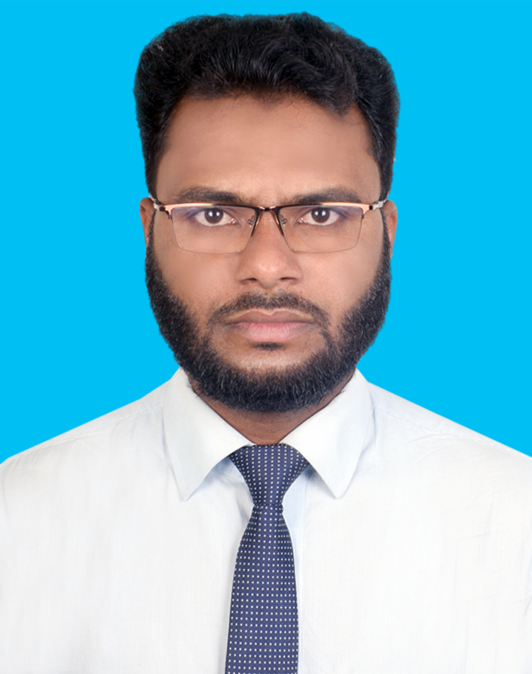

**MD.MAZNO DEWAN**

BSc. In Mechanical Engineering.

**Mailing Address**

Sonapahar & khilmurari,Zorargonj,Mirsharai,Chattogram.

**Cell: 01311605804**

**01885070977**

E-mail: mazno7031@gmail.com

**Carrier Objectives:**

To Work in an environment that challenges me to continue learning, at the same time is able to help and learn as much as I can from peers. To create a workspace that is in continual growth with opportunities for advancement.

**Experience**:

I have some experience about Auto CAD 2D. I have worked Aeronautical institute of Bangladesh at Lab Assistant. I have 2 years worked experience ZM International Project Engineer at Hydrant & Sprinkler System. I have 1.5 years worked experience Geo Welding Electrodes Ltd. Production Engineer & Mechanical Maintenance. Now I am continue my job at BSRM Wires Ltd. Production.

**Academic Credentials:**

**Name of Examination: S.S.C (**Secondary School Certificate)

Board : Dhaka

Institution : Raja Bari High School

Area : Business Studies

Result : G.P.A - 3.75 Out Of 5.00

Year of Passing : 2007

**Diploma Engineering (**Power)

Board : Bangladesh Technical Education Board Institution : Sylhet Polytechnic Institute

Area : Power Engineering

Result : C.G.P.A.-3.38 Out Of 4.00

Year of Passing : 2011

**Under Graduate:** BSc. in Mechanical Engineering.

Institution : IUBAT- International University of Business Agriculture and Technology

Result : C.G.P.A.-3.37 Out Of 4.00

Year of Passing :2018

**Self-Assessments:**

* Excellent skill in Communication.
* Able to set priorities and routine tasks.
* Optimistic, Confident and friendly as a person.
* High ethical standards and high sense of self-esteem.

**Computer Skills:**

* MS Office(2013,2010) Package including MS Word, Microsoft Excel, Power Point.
* Good control in Windows7, Windows8 & all kind of Internet related software.
* Have expertise on Browsing and mailing with Mozilla Firefox, Google Chrome and Opera & E-commerce.

**Industrial Training**:

1. Three (03) Month **Industrial Attachment** Program Automobile in **Karl Benz Auto Care, Tejgaon, 137/A, Dhaka.**

2. Ten (10) days Attachment Program in **PLC,** Bangladesh Industrial Technical Assistance Center (BITAC), Tejgaon Industrial Area, Dhaka.

3. Three (03) Month **Industrial Attachment** Program CNG Conversion System at NAVANA CNG LIMITED. Uttara, Dhaka.

**Personal Information:**

Father’s name : Md.Mahizuddin Dewan

Mother’s name : Fulmoti Begum

Date of birth : 10 August 1989.

Home district : Gazipur

Nationality : Bangladeshi

Religion : Islam

Marital status : Married Blood Group : A+ve

Sex :Male

Contact Number :01916291204

E-mail : [Mazno7031@gmail.com](mailto:Mazno7031@gmail.com)

**Permanent Address :** Vill: Kathaltoli, P.O:Kaliakair, P.S: Kaliakair, Dist: Gazipur.

**Interest:**

* Working in team and sharing ideas & views.
* To adapt and work it prevailing technologies taking place day by day.
* Reading Magazines, Computer Works, Traveling, Cricket & Football.

**Reference:**

|  |  |
| --- | --- |
| **Professor Engr.Abdul Wadud**  Professor & Coordinator (Mechanical)  IUBAT University  **Mobile: 01733566800** | **Md.Basher Ahamed**  Bcs( Technical Education)  Chief Instructor (Power)  Sylhet Polytechnic Institute  01552419461 |



Md.Mazno Dewan