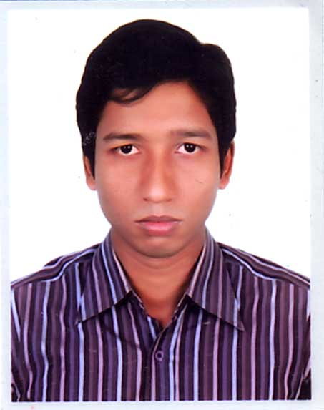

**RESUME**

**Md. Mahade Hassan**

**Preasent Addres**

House #20/B 5th Floor Mazar Road

B#E 1st colony Mirpur-1, Dhaka-1216.

Contact Number:01923-785894

Mail : [mahadehasanbc@gmail.com](mailto:mahadehasanbc@gmail.com)

**Career objective:**

Wishing to develop my career in the Multinational or National area and participate in effective activities in the concerned field to perform responsibility for growth, which offers a challenging environment to sere your company by sharing my ideas and experience knowledge and gave my best effort t achieve the aim of the company.

**International skill:**

1. Strong desire for leading an honest life with dignity.
2. Hard worker, sincere and eager to learn.
3. Self motivated individual with strong desire towards goal achievement.
4. Innovative and ability to work independently or in a group and under pressure.
5. Well disciplined and organized, presentable, energetic with excellent communication skills.

**Academic Qualification:**

|  |  |  |  |  |
| --- | --- | --- | --- | --- |
| **Exam Name** | **Passing Year** | **Group/Subject** | **Result** | **Board/University** |
| S.S.C | 2004 | Humanities | 2.44 | Jessore |
| H.S.C | 2007 | Humanities | 4.30 | Jessore |
| B.S.S | 2011 | Political Science | 2nd Class | National University |
| M.S.S | 2012 | Political Science | 1st Class | National University |

**Language Proficiency:**

­­­­

* Bengali : Mother Tongue
* English : Reading, Writing & Speaking.

**Computer Knowledge:**

* MS-Word, MS-Excel, Familiar with Internet & Browsing.

**Experience:**

Working as

1. **Position : SENIOR EXECUTIVE**

**Company Name: FINEX THREAD LIMITED**

Tejgoan, Dhaka

Department : Sales & Marketing

Duration : 1st March 2020 to Continue

2. **Position : EXECUTIVE**

**Company Name: SIMTEX INDUSTRIES LIMITED**

Khagan, Birulia , Savar , Dhaka

Department : Sales & Marketing

Duration : 24th May2017 -28th February 2020.

3. **Position**  : **MEDICAL PROMOTION OFFICER**

**Company Name: ALCO PHARMA LIMITED**

House# 21, Road # 113/A, Gulshan-2

Dhaka-1212 Tle : 8825336

Department : Sales & Marketing

Duration :2nd May 2014 -31st December 2016

4**. Position : Field Investigator**

**Company Name: The Nielsen Company Ltd**

Duration: 2nd October 2010 -1st December 2011.

House#70 (2nd Floor), Road# 15/A(new) Dhanmondi, R/A, Dhaka-1209.

Phone: 91

**Personal Information:**

Name : Md.Mahade Hassan

Father’s Name : Late Yeakub Ali Biswas

Mother’s Name : Mst. Daliman Nassa

Permanent address : Vill: Padmanagor P.O:Kumiradha

P.S:Shalailakupa Dist: Jhenidha

Sex : Male

Date of Birth : 30November 1988

Nationality : Bangladeshi (By birth)

Religion : Islam (Sunni)

Marital Status : Married

Height : 5 feet 9 ince

**Reference:**

**Thanjida Haq**

Ass. Professor (Political Science Department)

Govt. Bangla college, Mipur-1

Dhaka-1216.

Mobile : 01786001997

Md. Mahade Hassan

Date:……………………….