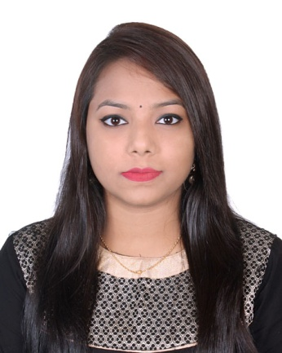**RESUME**

**OF**

**Maria D' Costa**

South Kafrul, Dhaka Cantonment,

Dhaka-1206

Contact No: 01631844908

E-mail: mariacosta0629@gmail.com

**Objectives:**

Looking for a job where there is an opportunity to apply knowledge to pursue a professional career in a reputed dynamic organization that provides an excellent job environment for career growth and practices a professional performance culture where quality is recognized and rewarded.

**Profile summary:**

* Ability to work under pressure.
* Eagerness to take up new challenges.
* Ability to meet deadlines through effective time management.
* Ability to Buildup rapport with all the team members.

**Career objective:**

* Sudden creative problem solving skills.
* Problem solving skills and profound logical judgment.
* Effective team player with, interpersonal, communication and presentation skills.

**Educational Qualification:**

**MAE (In English)**

* Institute : NORTHERN UNIVERSITY BANGLADESH
* Degree : Masters of Arts
* Department : English Language and Literature
* CGPA : 3.3 out of 4
* Year : 2017-2018

**ELL (English Language and Literature)**

* Institute : NORTHERN UNIVERSITY BANGLADESH
* Degree : BA (Honors) 4 Years
* Department : English Language and Literature
* CGPA : 3.83 out of 4
* Year : 2013-2017

**H.S.C (Higher Secondary School Certificate)**

* Institute : Holy Cross College
* Group : Humanities
* Result : GPA- 4.00
* Year of passing : 2012
* Board : Dhaka

**S.S.C (Secondary School Certificate)**

* Institute : Holy Cross Girls' HighSchool
* Group : Humanities
* Result : GPA-4.44
* Year of passing : 2010
* Board : Dhaka

**Others Qualification:**

**Computer Skill:**

* Operating Systems : Windows XP, Windows 7, Windows 8, 8.1, 10.
* Hardware Management : Basic
* Subjects : Microsoft Word, Network Browsing,

Microsoft Power Point,

**Language Skill:**

|  |  |  |  |
| --- | --- | --- | --- |
| **Subject** | **Speaking** | **Reading** | **Writing** |
| Bengali | Excellent | Excellent | Excellent |
| English | Excellent | Excellent | Excellent |

**Job Experience:**

* Previously worked as an **Executive Officer** in HR & Admin Department at **ASSURANCE DEVELOPEMENT LIMITED** since May 2017 to June 2018.
* Previously worked as a **HR Officer** in Human Resource Department at **SOUTH CHINA BLEACHING & DYEING FACTORY LTD.** since June 2018 to June 2019
* Previously worked at "Whisper" Project as a Direct Marking Executive in Sales & Marking Department at ICREATION since july 2019 to April 2020.

**Lingual Capability**

Bengali : Mother Language

English : Fluent in speaking.

**Interest:**

Reading novels, Magazine, Writing and Traveling.

**Personal Information:**

Name : Maria Shadona D' Costa

Father’s name : Joseph Swapon D' Costa

Mother’s name : Teresa Lily D' Costa

Present Address : South Kafrul, Cantonment, Dhaka-1206

Permanent Address : G.P Chha-13, Mohakhali T B Get, Gulshan Dhaka-1212

Date of birth : 29 December 1992

Nationality : Bangladeshi by birth

Marital status : Married

Religion : Christian (Catholic)

**References:**

1. Victor Stany Rozario

*Assistant Professor*

Department of Computer Science

American International University-Bangladesh.

Phone: 01676517671

Email: stany@aiub.edu

**Signature:**