Summary

To work for a dynamic and renowned organization that renders growing and learning opportunities through responsibilities and motivation.

Skill Highlights

|  |  |
| --- | --- |
| * Project management * Strong decision maker * Complex problem solver | * Digital Marketing * Innovative * Service-focused |

Experience

* **Business Development Executive** In Ti Tailor.
* Worked as a **Sub Editor** From 01st May, 2017 to 14th September, 2017 at **Eikhobor.com**
* Worked in an e-ccommerce site in 2019. Name **Dinpon**.
* Team Leader in Daffodil Internationl University (Art Of Living)

-Responsible for the entire project handeling process.

-Managed a team of ten member.

Education

**Bachelor of Business Administration (BBA)**

Institution: Daffodil International University.

Major: Human Resource Management

Result: GPA **3.02** out of **4.00**

Year of passing: 2020

**Higher Secondary Certificate (H.S.C)**

Institution: Jashore Shikkha Board Model School And Collage

Group: Business Studies.

Result: GPA **4.00** out of **5.00**

Year of passing: 2014

**Secondary School Certificate (S.S.C)**

Institution: Jashore Zilla School, Jashore

Group: Business Studies.

Result: GPA **4.31** out of **5.00**

Year of passing: 2012

Contact

**Address:**

7 No Sector,New Market, Jashore

**Phone:**

01681360653

**Email:**

[sabitalsakir32@gmail.com](mailto:sabitalsakir32@gmail.com)

Languages

English – Good

Bengali – Excellent

Computer Literacy

* **Office Application:** M.S Word, M.S Excel, M.S Power Point.
* **Enough Knowledge On Digital Marketing.**
* **Google Trend Marketing.**
* **Excellent Internet Basics.**

Sabit Al Sakir

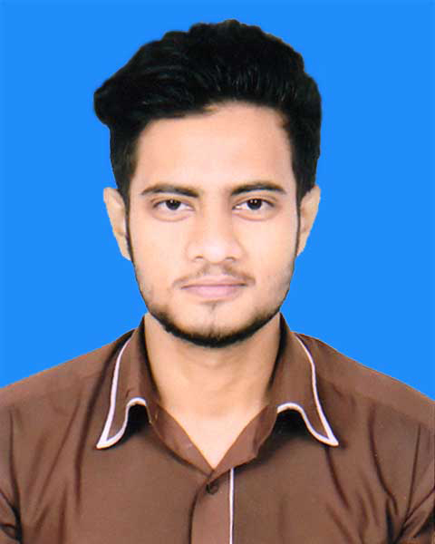

**KEY COMPETENCES:**

* Energetic, Creative, Promising.
* Ability to work under pressure to achieve the objective of the organization.
* Good interpersonal communication and Co-operative skill.
* Strong Leadership qualities to direct a team.
* Capable to work at any place determined by the organization.

**REFERENCES:**

Name: **Mohammed Samiul Islam**

Designation: Senior Executive

Organization: MGH Group

Mobile: +8801708-169095

E-mail: samiul.islam@mgx.com

**Sabit Al Sakir**