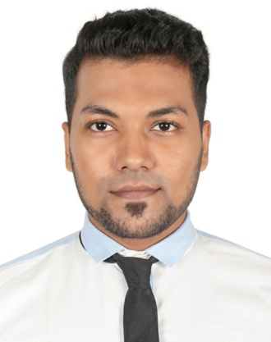

**Resume**

**of**

**MD. Bappy**

**Mailing Address**

**House No : 23/2 Sikkatuli lean Bangshal, Dhaka-1100**

**Cell Phone : 01622732779, 01780099675**

**Email : arnobahmed4642@gmail.com**

**Career Objective**

To build a long-term career in my profession with opportunities for career growth, to use my skills in the best possible way for achieving the company’s goals and rewarding careerposition within an organization where I can enhance me as experience and my education as well as offer growth opportunity.

**Educational Qualification**

|  |  |  |  |  |
| --- | --- | --- | --- | --- |
| Exam Title | Concentration/Major | Institute | Result | Passing Year |
| MBA | **Finance** | **University Of Development Alternative (UODA)** | **CGPA:3.16** | **2019** |
| BBA | **Marketing** | **University Of Development Alternative (UODA)** | **CGPA:2.46** | **2017** |
|  |  |  |  |  |
| HSC | **Business Studies** | **Bir Shrestho Munshi Abdur Rauf Rifles College.** | **GPA:3.00 out of 5** | **2011** |
| SSC | **Business Studies** | **Ahmed Bawani Academy** | **GPA:4.13 out of 5** | **2009** |

**Language Proficiency**

|  |  |  |  |  |
| --- | --- | --- | --- | --- |
| **Languages** | **Reading** | **Writing** | **Listening** | **Speaking** |
| **Bengali** | Excellent | Excellent | Excellent | Excellent |
| **English** | Excellent | Excellent | Excellent | Excellent |

**Computer Skills**

* **Application Program**: MS Office (Any Version), Adobe Page Maker
* **Operating System**: Windows (Any version)
* **Ecommerce:** Internet Browsing, Email Marketing, Online marketing, Affiliate Marketing and other online outsourcing related jobs.
* **Hardware**: Computer Assembling, Trouble Shooting & Maintenance etc. Hardware and software solution for Desktop and laptop.

**Capabilities and Interests**

|  |  |
| --- | --- |
| * **Strengths** * **Extra Curriculum** * **PersonalSkills** | * Ability to work under pressure to meet deadlines. * Self-motivated and committed to meet goals and objectives. * Ability to adjust and adapt to varying management approaches through strong interpersonal relation Address * Team building and Strong negotiation skills,adaptability and work independently, strategic thinking ability and Pro-active |
|  |  |

**PersonalProfile**

Name : MD. Bappy

Father’s Name : (Late)Nazim Uddin

Mother’s Name : Salma Begum

Date of Birth : 27 Dec, 1993

Gender : Male

Marital Status : Single

Nationality : Bangladeshi

NID : 640 880 6831

Religion : Muslim

Permanent Address : 23/2 Sikkatuli lean Bangshal, Dhaka-1100

**Experiences**

|  |  |
| --- | --- |
| **Company : Grameen Uniqlo.**  **Position : Sells Executive**  **Department :** Sales and Marketing  **Time Period : Eid festival at 2016** | **Company : Cats Eye**  **Position :** Sales Associate  **Department :** Sales and Marketing  **Time Period : Eid festival at 2015** |
| **Company : Comfort Co. Panthapath Dhaka.**  **Position : Volunteer**  **Department :** Marketing & Sales **Time Period : 2014** | **Company :** Pran –RFL company LTD  **Position :** Supervisor **Department :** Marketing & Sales **Time Period : 2016** |
| **Company : Digicon Technologies Limited (Authorized by Robi Axiata Limited)**  **Position : Executive Compliance Management**  **Department : Airtel Complaint Management Time Period : 2019** |  |

|  |  |
| --- | --- |
|  |  |

**Declaration**

I the undersigned declared that to the best of my knowledge and belief that these data correctly describable my qualification.

**Signature**

________________

MD. Bappy