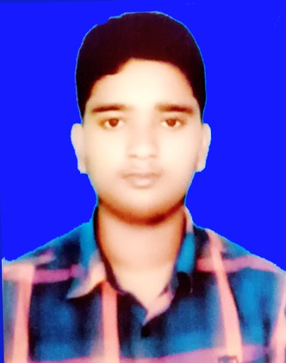**Curriculum Vitae**

**of**

**Redoy Mondol**

Contact: 01905-058237

Email: [hridoymondal422@gmail.com](mailto:hridoymondal422@gmail.com)

**Personal Information** :

Name : Redoy Mondol

Father’s Name : Somir Mondol

Mother’s Name : Nipa Rani Mondol

Date of Birth : 08-02-1999

Nationnality : Bangladeshi

Religion : Hindu

Hight : 5' Feet -8''inc

Blood Group : O ( +)

Present Address : Village: Pakuria

Post Office: Amdia

Police Station : Narsingdi Sadar

Dist- Narsingdi

Permanent Address : Village: Pakuria

Post Office: Amdia

Police Station : Narsingdi Sadar

Dist- Narsingdi

**Educational Qualification :**

|  |  |  |  |  |
| --- | --- | --- | --- | --- |
| Name Of Exam | Group | Passing Years | G.P. A | Board |
| S.S.C | Business Studies | 2015 | 3.06 | Dhaka |
| H.S.C | Business Studies | 2017 | 3.80 | Dhaka |

**Experience :**Vivo Mobile Factory in Bangladesh .

Packing Line Monitor ,

Production, Department

Kusabo, Rupgonj , Narayongonj,1.5 years .

......................

Signature: