**Resume**

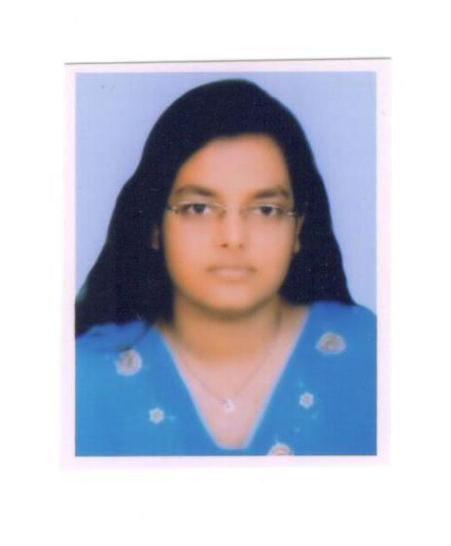

**Of**

**JannatunAra Begum**

Mob:+88-01737-307508

Mail: [jannatun508@gmail.com](mailto:jannatun508@gmail.com)

Career Objective : To reach the apex position of Accounts sector by

sowing quality, performance and creativity.

Working Experience : 1) In the year of 2007 to 2009 as a Customer Care

in Computer Division of Warid Telecom at

Dinajpur Franchise.

2) From the 2009 to 2015 as a Computer Operator and Accountant of M.R.Group at Dinajpur.

3) From the 2015 to 2018as a Accounts Officer and

IT Officer of Jewel Traders at Dinajpur.

4) From the 2018 to 2019 as a IT In charge of Unilever Bangladesh Ltd. Distributor of Jewel Traders

**Educational Qualification:**

1. S.S.C (Secondary School Certificate): Year of Passing: 2006

Result: GPA 3.81

Group: Science

Board: Rajshahi Board.

1. H.S.C (Higher Secondary Certificate): Year of Passing: 2008

Result: GPA 3.60

Group: Commerce

Board: Rajshahi Board.

1. B.B.S (Bachelor of Business Studies): Year of Passing: 2011

Result: 2nd Division

Board:National University.

1. M.B.A (Bechelor of Master’s Administration): Year of Passing: 2019

Result: GPA 2.66

Group: Management

Board: National Universit

Key Strength: Achievement Oriented

Self-motivated

Fast Learner

Punctual and Honest.

Communication Skill : Have a Communication skill in both

English & Bengali.

Computer Literacy : Packaging:

1. Office (MS Word, MS Excel)
2. Typing Speed:

Bangla: 25 Wpm

English: 25 Wpm

1. Email, Internet Operation & MIS System

**Personal Profile:**

1. Father Name : Samaun Sarker.
2. Mother Name : Afsari Begum.
3. Husband Name : Md. Moklesur Rahman.
4. Present Address : Block No-6/A, Quarter No- N/8, Newtown,

Dinajpur.

1. Permanent Address : Block No-6/A, Quarter No- N/8, Newtown,

Dinajpur.

1. Home District : Dinajpur.
2. Date of Birth : 31/12/1990.
3. Marital Status : Married.
4. Sex : Female.
5. Religion : Islam.
6. Nationality : Bangladeshi (By Birth).
7. Blood Group : O+
8. National ID No : 5096480107

I hereby certify that all the information given is fully true according to my knowledge and document.