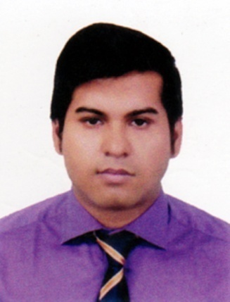**RESUME**

**OF**

**MOLLA IMRANUL MALIQUE**

Cell: 01630841274

E-mail:mimaleak@gmail.com

**Present Address:**

**CAREER OBJECTIVE:**

Strong desires to be an efficient executive as well as would like to work in a structured organization having challenges with friendly environment where career buildup opportunity exists.

**EDUCATIONAL QUALIFICATION:**

**M.B.A (Masters of Business Administration)**

Institution : Jahangirnagor University

Subject : Finance & Banking

Result : 3.19(Out of 4)

Passing year : 2019

**B.B.A (Bachelor of Business Administration)**

Institution : Tejgaon College

Subject : Finance

University : National University

Result : 3.12 (Out of 4)

Passing Year : 2014

**Higher Secondary Certificate (H.S.C)**

Institution : Dhaka Commerce College

Group : Business Studies

Board : Dhaka

Passing Year : 2010

Result : 4.60 (Out of 5)

**Secondary School Certificate (S.S.C)**

Institution : Mohammadpur Uchcha Madhyamic Model Bidyalaya

Group : Business Studies

Board : Dhaka

Passing Year : 2008

Result : 4.88 (Out of 5)

**Skill:**

Interpersonal Skill : Ability to deal with diverse type of people in a friendly and Familiar manner.

Language Skill : Bengali & English good in speaking, Reading & writing.

Computer Skill : Operating System: Ms Word,Excel, Power Point, Internet Browsing & E- mail.

**Internship**

**I complete my Internship at southeast Bank Mohammadpur branch (February to May 2016)**

**Responsibility:**

* Sending Sales to people to Customer with information
* Collection & Verification of Documents
* Collection of Cheque & information about the new accounts
* Data entry in software for production
* Daily cheque entry in manually
* Sometimes cheque clearing by myself

**PERSONAL BACKGROUND**

* Goal oriented & hard working.
* Able to adapt in new environment & love to take challenge.
* Planning & organizing ability

**PERSONAL INFORMATION:**

Name : Molla Imranul Malique

Father's Name : Dr. Molla Azfarul Haque

Mother's Name : Hosne Ara Begum

Permanent Address : 233, Sher Shah Suri Road, Mohammadpur, Dhaka-1207

Present Address : 233, Sher Shah Suri Road, Mohammadpur, Dhaka-1207

Date of Birth : 01-02-1993

Religion : Islam

Sex : Male

Nationality : Bangladeshi by birth

Marital Status : Single



1. **Dhaleshwari limited:** (Gulshan)(From August 2016 –continuing)

**Designation: Executive Officer**

**Responsibility:**

# Work Order Collection

# Prepare all types of delivery report.

# Handle every bank account and loan account.

# Prepare all types of vouchers, salary sheet, income statement sheet, inventory sheet, cash statement, loan account.

#Prepare final asset and liabilities sheet as semiannually and yearly basis.

# To communicate customers in different ways

**Reference:**

**Wazir Ahmed Fateh**

Deputy Accountant General(senior)

A.G. Office, Dhaka

Mobile:01711593390

**Abdur Rashid Mazumder**

Chairman, Impress Group

Tejgaon, Dhaka

Mobile:01711520687

-------------

--------------------

Signature