**SANJAY KUMAR DEBNATH**

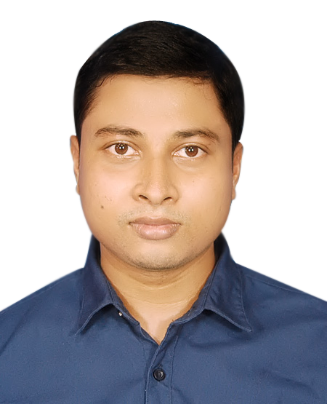

11/4,Block-D

Solimullah Road,Mohammadpur,Dhaka- 1207

Email:Sanjoydebnath7123@gmail.com

Mobile no : 01857092085

**Career Objectives**

­To secure a position where my strengths as a hardworking dedicated fast-learner, skills in organizational ability, communication & research and my innovative ideas can be utilized by a dynamic organization.

|  |
| --- |
| **Summary of Educational Qualification** |

|  |  |  |  |  |
| --- | --- | --- | --- | --- |
| **Degree** | **Institution & Board** | **Subject** | **Results** | **Year of passing** |
| Bachelor of Science | University of Information Technology & Science | Electrical and Electronic Engineering (EEE) | CGPA-3.41 | 2020 |
| H.S.C. | Adhyapak Abdul Mazid College, Comilla Board | Science | GPA-3.50 | 2010 |
| S.S.C. | R M Hat K High School,  Comilla Board | Science | GPA-4.44 | 2008 |

|  |
| --- |
| **Language Proficiency** |

* Native command in English both in written and oral form
* Native speaker of Bengali

|  |
| --- |
| **Computer Literacy** |

* Can efficiently use a number of applications in MS Office package including Words, Excel & PowerPoint and Internet based software.

|  |
| --- |
| **Communication Skills** |

* Research & Report writing
* Presentation & Public speaking

|  |
| --- |
|  |
| **Traits** |
|  |

* Energetic, Enthusiastic, Self-motivated & Innovative
* Good Interpersonal, Communication & Motivation skills
* Quick Analytical Ability
* Good Organizational Ability
* Ability to work in teams or independently
* Ability to adapt to any environment & work under any situation

|  |
| --- |
| **Personal Details** |

|  |  |  |
| --- | --- | --- |
| Date of Birth | : | 1992,16 June |
| Nationality  ParmanentAddress | :  : | Bangladeshi  Vill:Soforpur,P.S:Sonagazi,P.O:Ahammadpur,  Dist: Feni |
| Religion | : | Hinduism |
| Marital Status | : | Unmarried |
| Sex | : | Male |
| Height | : | 5’5” inch |
| Weight | : | 55Kg |
| Blood Group | : | A+ve |
|  |  |  |
| Father | : | Dilip Kumar Debnath |
| Mother | : | Putul Bala Devi |
|  |  |  |
| Interests | : | Travelling,Reading,Music,Movies,Mechanical |

……….………………………

Signature

(Sanjay Kumar Debnath)