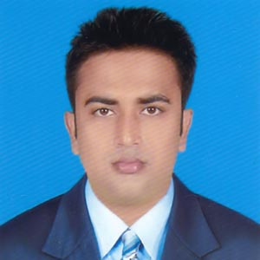**CURRICULUM VITAE**

**MD.RAZIB MIRZA**

**Career Objective**

* To work with an organization and prove the potentiality through hard work, efficiency, enthusiasm and integrity.
* To attain practical experience that can be used for further improvement of the organization as well as for development work.
* To build an economically sound carrier with honesty.

**Educational Pursuits**

***B.B.A (Hon.)***

* Institution : Shahid Smriti Govt. College, Muktagacha, Mymensingh.
* University : National University.
* Subject : Management.
* Year of Passing : 2017
* C.G.P.A : 2.74

**Higher Secondary Certificate (HSC)**

* Institution : Shahid Smriti Govt. College, Muktagacha, Mymensingh.
* Board : Dhaka.
* Group : Business Studies.
* Year of Passing : 2013.
* G.P.A : 3.60.

**Secondary School Certificate (SSC)**

* Institution : [R.K. High School, Muktagacha, Mymensingh](https://www.facebook.com/pages/RK-High-School-MuktagachaMymensingh/360877254002148).
* Board : Dhaka.
* Group : Business Studies.
* Year of Passing : 2011.
* G.P.A : 4.06.

**Computer Skill**

* Spared sheet work though MS-Excel.
* Word-processing though MS-Word.
* Make Presentation through MS-PowerPoint.
* Able to operation E-mail Application Software & Software Operation.

**Language Known………**

**…………**

**English** : (Fluent In Reading, Writing and Speaking).

**Bangla** : Native language.

**Personal details**

Name : Md. Razib Mirza

Father’s Name : Md. Dudu Mirza.

Mother’s Name : Laily Begum.

Permanent Address : Vill: Iswargram, P.o.: Muktagachha,

P.s: Muktagachha, Dist: Mymensingh.

Present\ Mailing Address : Vill: Iswargram, P.o.: Muktagachha

P.s: Muktagachha, Dist: Mymensingh.

Mobile No. : 01985-585194.

Date of Birth : 30th May 1995.

Nationality : Bangladeshi (By Birth).

Native Language : Bengali.

Religion : Islam.

Marital Status : Single.

Sex : Male.

Blood Group : O+ (Ve).

I the undersigned, declare that the above is true and correct to be best of my knowledge and belief. These data correctly describe my qualification and me.

**Signature of applicant**

**Md. Razib Mirza**

Date: 10/10/2019