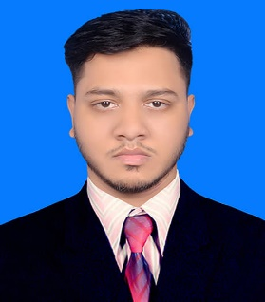**CURRICULUM VITAE**

**OF**

**MD ASADUZZAMAN**

**CELL NO. 01646737308**

**Email: asaduzzaman.su9001@gmail.com**

* **CAREER OBJECTIVE :**

In line with my continued interest and performance in B.Sc in Mechanical Engineering . I have decided to build up my career in the professional field. So, I would like to show my immense aspiration to become a quick learner and to prove myself as a sincere and energetic person through extensive hard working and integrity.

* **PROJECT & INTERNSHIP:**
* Project on “**Highway** **Road Side vertical Turbine**”

and used for Traffic signal light, Road light etc.

* **EDUCATIONAL QUALIFICATION :**

**B.Sc in Mechanical Engineering:**

Institute Name : Sonargaon University

Department : Mechanical Engineering

C.G.P.A : 3.08

Passing Year : 2020 (Summer)

**Higher Secondary School Certificate(H.S.C)** :

Collage Name : Hafez Ziaur Rahman College

Board : Dhaka

Group : Science

G.P.A. : 3.67(out of 5)

Passing Year : 2015

**Secondary School Certificate (S.S.C) :**

School Name : Bhugi Jawani High School

Board : Dhaka

Group : Science

G.P.A. : 3.88 (out of 5)

Passing Year : 2013

* **PERSONAL DETAILS :**

Name : Md Asaduzzaman

Fathers Name : Md Joynal Abedin

Mothers Name : Sakhina Begum

Date of Birth : 09 May 1997

Blood Group : O- (Ve)

Marital status : Unmarried

Religion : Islam

Nationality : Bangladeshi (By Birth)

Height : 5‘ - 7‘’

Sex : Male

* **PRESENT & PERMANENT ADDRESS :**

Vill: Pailaty P.O : Pailaty

P.S: Purbadhala Dist : Netrakona

* **COMPUTER SKILLS :**
* Word processing Microsoft Word
* Spread Sheet Analysis Microsoft Excel
* **LANGUAGE SKILLS :**
* Bengali : Better reading, writing & speaking.
* English : Good Reading, writing & speaking.
* **MY INTEREST :**
* Reading books, Listening music, Watching movies, Football, Cricket.
* **DECLARATION :**

I declare that all the information included here are true to my knowledge. If required and where applicable, this document can be supported by appropriate authentic certificate.

**MD ASADUZZMAN**