**CURRICULUM VITAE**

**Of**

**Clinton Biswas**

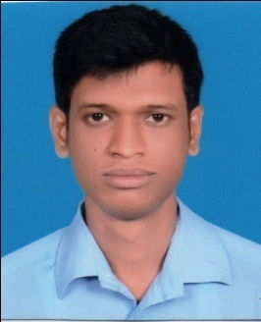

**Contact Address:**

72/6, D Type government officers’ quarter,

Paikpara, Mirpur-1, Dhaka – 1216

Contact No: 01673141398 / 01726071181

Mail: clintonbiswas23@gmail.com

**CAREER OBJECTIVE:**

In my career I would like to have a position where I can properly utilize my education and work at challenge. I desire to work in an organization that has the reputation for excellence. For your kind concern I find this job very interesting.

**ACADEMIC QUALIFICATION**:

**Master’s of Business Administration (MBA)**

Passing year: 2020

Major : Marketing

Result : 3.14 (out of 4)

Institute: Jahangirnagor University (IBA-JU)

**B.Sc in Textile Engineering**

Passing Year: 2017

Major: Wet Processing Technology (Dyeing)

Institution: Bangladesh University of Business & Technology (BUBT)

Result:3.62 (out of 4).

**Higher Secondary Certificate (H.S.C)**

Passing Year: 2012

Result: 5.00 (out of 5)

Discipline: Science

Board: Dhaka

Institute: Notre Dame College, Motijheel, Dhaka.

**Secondary School Certificate (S.S.C)**

Passing Year: 2010

Result: 5.00 (out of 5)

Discipline: Science

Board: Dhaka

Institute: Model Academy, Mirpur -1, Dhaka.

**Achivement:** Merchendising training from NITER for 2 months.

**Interne:** Norban Comtex Ltd (For two months).

**Experience:** 1 years experience from JARE FASHION as an assistant merchandiser.

**Computer skills:** MS Office Package (Microsoft Word, Microsoft Excel, Microsoft Power

Point).Internet Browsing, E-mail.

**Language Skills:** Bangla and English (Excellent in reading, writing and speaking).

**Personal Information:**

Name : Clinton Biswas

Father’s Name : Dulal Biswas

Mother’s Name : Anima Biswas

Present Address : Building-4/A; Flat-6/c; E type staff quarter; Ansarcamp;

Mirpur-1; Dhaka-1216.

Permanent Address : Holding-478; Union-06 Kushla; Village-Lakhirpar; Post- Radhagonj; District- Gopalgonj

Date of Birth : 28/10/1994

Marital Status : Unmarried

Height : 178 cm

Weight : 60 kg

Blood Group : B+ (Positive)

Religion : Christian

Nationality : Bngladeshi (By Birth)

National Id No. : 19942694811000616

**Declaration:**

I am declining that all the above information is true and correct to the best of my acknowledged.

Clinton biswas

…………………..

Clinton Biswas