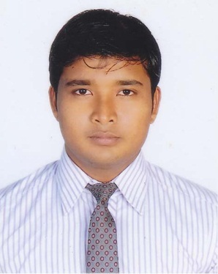**Resume**

**Of**

**Mahabub Kabir**

4/4(4th Floor)Probal Housing,Adabor, Dhaka 1207

E-mail: mahabub[k28@gmail.com](mailto:k28@gmail.com)

Phone: +8801751519410

**Objective:**

Serve in a responsible position at a well-structured organization and successfully apply acquired managerial and interpersonal skills to enhance organizational efficiencies. To establish in a challenging environment & gather knowledge and experience. Enter in a goal oriented and challenging job environment where the standard of work in high and opportunities to develop myself.

**Education Qualification:**

**Master of Business Administration**

Institution : University of Liberal Arts Bangladesh (ULAB)

Passing Year : Continue

Major Subject : Accounting

**Bachelor of Business Administration**

Institution : University of Development Alternative (UODA)

Passing Year : 2016

Major Subject : Accounting

Result : 3.42 out of 4.00

**Higher Secondary Certificate**

Institution : College Of Development Alternative (CODA)

Passing Year : 2012

Subject : Business Studies

Result : 4.60 out of 5.00

**Secondary School Certificate**

Institution : Mirpur Bangla High School&College

Passing Year : 2010

Subject : Business Studies

Result : 3.88 out of 5.00

**Highlights Of Abilities:**

* Excellent Representation
* Creative Thinker
* Good Communication Skill
* Positive Attitude
* Good Looking
* Dedication

**Language Proficiency:**

Bangle (as native)

English(skilful in Speaking and writing)

**Computer Proficiency:**

Skilled in Ms Word, Ms Power Point, Ms Excel

Windows xp, Windows 2007, Windows 2008,and Internet access.

**Other Skills:**

Onilne Lead Genaration,Social Media Marketing,Digital Marketing,Tally.ERP9

**Interests:**

Cricket, football, Traveling, Reading Novels and event organizing.

**Achievement:**

Captain of champion team at 2011 in CODA

**Personal Profile:**

Name : Mahabub Kabir

Father’s name : Md. Mojir Uddin

Mother’s name : Morjina Khatun

Present address : 4/4(4th Floor)Probal Housing,Adabor-1207

Permanent address : Biharipara,Puthiya,Rajshahi-6062

Nationality : Bangladeshi (by born)

Religion : Islam

Date of birth : 25 December,1995

Gender : Male

Marital status : Single

**Experience:**-

**ISSL(Impel Service & Solution Ltd) Union BD Consumer Ltd**

Robi Mobile Insurance (Out Bounding) Sales Dept.

Call Centre Agent Sales Support

Worked at 1 Year Still Working

**Ekhanei.com Haque Limited**

Marketing Dept. Finance & Accounts Dept.

Brand Promoter Intern

Worked at 1 year 4 month