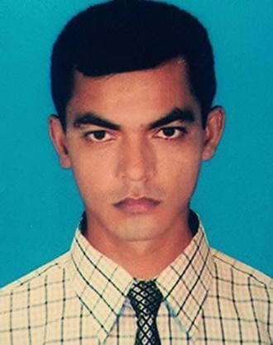**RESUME**

**Of**

**(Md. Rabbinur Islam)**

Vill: Sonar Gaon, Post: Chikashi,

P.S: Dhunat, Dist: Bogra.

Contact No: 01719-826260

email: rabbinur14@gmail.com

***Objective:***

To prove myself as a quick learner and highly energetic person to face any challenge and to build up my career in such an organization in the field of marketing sector, Banking sector, Garments sector of non-government organization or any service oriented company where the contribution will be acknowledge, if would be given any opportunity.

**Biography**

1. Name : **Md. Rabbinur Islam**

2. Father's Name : Md. Shahidul Islam Akanda

3. Mother's Name : Mst. Rekha Khatun

4. Present Address : Vill: Sonar Gaon, Post: Chikashi,

P.S: Dhunat, Dist: Bogura.

5. Permanent Address : Vill: Sonar Gaon, Post: Chikashi,

P.S: Dhunat, Dist: Bogura.

6. Date of Birth : 08/10/1987

7. Nationality : Bangladeshi

8. Religion : Islam

9. Sex : Male

10. Marital Status : Married

11. Height : 5 Feet 4 Inch.

12. Weight : 52 Kg.

***PERSONAL ATTRIBUTES:***

➲ Good organization and interpersonal communication skill.

➲ Ability to work in any environment.

➲ Self confident being positive.

➲ Open mind in adapted to new challenge situation.

**Educational qualification**

***Bachelor of Business Studies (B.B.S):***

Institution : Dhunat Degree College, Bogra.

Group : Business Studies

Result : 2nd Division

Passing Year : 2010

Board : National University

***Higher Secondary School Certificate (H.S.C):***

Institution : Goshainbari Degree College, Bogra.

Group : Commerce

G.P.A : 3.00

Passing Year : 2005

Board : Rajshahi

***Secondary School Certificate (S.S.C):***

Institution : Sonar Gaon High School, Bogra.

Group : Science

G.P.A : 2.13

Passing Year : 2003

Board : Rajshahi

***Language Proficiency:***

Good communication skill on both speaking and writing in English and Bangla.

***Computer Skill:***

Introduction to PC and operating system, MS-Word, MS Excel, Ms Power point, Ms-Access, Internet Browsing .

***Experience :***

1. Operational Manager of Cybertech System & Software Technologies Ltd.
2. Computer Operator of Barmon Health Care, Sherpur, Bogra.
3. Sales Officer of National Polymer Ind. Ltd

***Interest and Hobbies:*** I have an interested in variety of sports (Cricket, Football). To relax enjoy reading, listening to music and watching drama. I like visiting natural place and fishing by well.

***Reference:***

2. Md. Zamal Uddin

Assistant Headmaster

Sonar Gaon High School

Mobile: 01709-949993

1. Md. Fakhrul Islam

Dresser,

Rural Development Academy

R. D. A. Bogra.

Mobile: 01738-541188

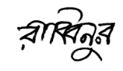

Date- **18/08/2021 Signature**