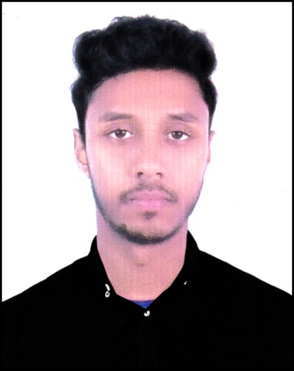 **CURRICULUM VITAE**

**OF**

**MD. AKRAM HOSSAIN**

**Present Address**

Md. Akram Hossain

C/O: Md. Ashraful Islam

Vill: Surhatti, P.O: Rasulpur,

P.S: Patnitala, District: Naogaon.

**Mobile: 01729-754040**

Career Objective:

Looking for hard and challenging job where I will have the scope to utilize my potentiality, adaptability and skill to do something innovative and from where I will be able to enhance my competence.

My reliability, communication skills, responsibility and friendly behavior are my assets that I would like to bring the work.

Education;

Higher Secondary certificate (H.S.C)

* Institution : Chowrat Shibpur Barendra College, Naogaon
* Passing Year : 2021
* Result : GPA- 4.58 (out of 5 scale)
* Board : Dhaka
* Group : Business Management

Secondary School certificate (S.S.C)

* Institution : Shibpur High School
* Passing Year : 2016
* Result : GPA- 4.39 (out of 5 scale)
* Board : Rajshahi.
* Group : Science

**Computer Skills:**

* Basic knowledge of computer of system unit.
* Computer Office Application.
* Internet Explorer and E-mail.

Profiles:

Name : Md. Akram Hossain

Father's Name : Md. Ashraful Islam

Mother's Name : Mst. Aklima Khatun

Permanent Address : Vill- Surhatti, Post- Rasulpur,

Upazila.- Patnitala, Dist- Naogaon.

Present Address : Vill- Surhatti, Post- Rasulpur,

Upazila.- Patnitala, Dist- Naogaon.

Nationality : Bangladeshi

Religion : Islam

Date of Birth : 29/03/2000

Sex : Male

Marital Status : Unmarried

Height : 5.6″

Blood Group : O**+** (Positive)

Weight : 54 kg

Home District : Naogaon.

National ID No : 5562228824

Language Competency:

Have an excellent command over English & Bengali Languages in both speaking, writing & listening.

Personal Skills:

. Have a positive passion on creative writing also have the efficiency on new

reporting and editing.

. Hard worker, self-driven and change oriented.

. Have positive attitude to my responsibility.

. Proficient in report writing and oral presentation.

. Have strong analytical, problem solving and decision making ability.

. Have ability to work under pressure and adapt given situation.

I hereby declare that the above statements are correct and complete to the best of my knowledge.

Signature



...............................

(Md. Akram Hossain)

Date: