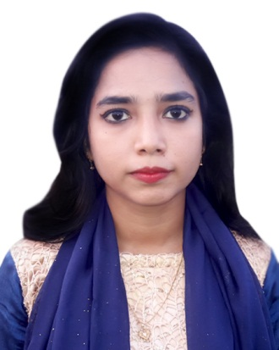**CURRICULUM VITAE**

**BIPASHA RANI MONDOL**

Contact & Address:

Cell no: 01741279778

E-mail: bipasha7090@gmail.com

Address: Taherpur, Manirampur, Jessore,

OBJECTIVE

To work in an environment where there is an opportunity of self assessment and self improvement in both individual and group bases work that will ultimately lead to further development of the common people.

EDUCATION

**Exam**  : **Secondary School Certificate Examination, 2009 (SSC).**

Session : 2007-2008

Institution : Manirampur adarsha secondary school, jessore.

Board : jessore

Result : 4.19 Out Of 5 (A).

**Exam** : **Higher Secondary Certificate Examination, 2011** (**HSC).**

Session : 2009-2010

Institution : Monirampur Mahila College Jessore.

Board : jessore

Result : 3.90 Out Of 5 (A-).

**Exam** : Bachelor of Business Administration (**B.B.A) 2016.**

Session : 2012-2013

Institution : Southern Institute Of Business And Information Technology, Jessore.

Board : National University.

Result : 2.66 Out Of 4 (B-)

**PERSONAL STRENGTHS**

♣ Honest and responsible.

♣ Self-confident, Punctual, Realistic & Hard worker.

♣ Excellent Inter-personal communication skill.

♣ Able to manage & work under pressure.

**EXPERIENCE**

♣ 3 Month Long Internship On Human Resource Management .

**COMPUTER SKILLS**

♣ Microsoft office, Microsoft Excel, Powerpoint .

♣ E-mail

♣ Internet Browsing.

LANGUAGE SKILLS

♣ Bengali

♣ English

**PERSONAL INFORMATIONS**

**NAME IN FULL : BIPASHA RANI MONDOL**

Father's Name : Subod Kumar Mondol

Mother's Name : Lilima Rani Mondol

Address (Present) : Vill: Taherpur, Post: Manirampur, Th: Manirampur, Dis: jessore, Bangladesh

Date of Birth : 12/08/1993

Marital Status : Single

Sex : Female

Nationality : Bangladeshi

Place of Birth : Jessore

**REFERENCES**

|  |  |
| --- | --- |
| **PROBIR KUMAR MITTRA**  Assistant professor  Basic science Department  Potuakhali Science & Technology University  +8801723424428 | **SHAHEEN SHAH**  Lecturer  Petroleum & Mining Department  Jessore Science & Technology University  +8801710785055 |

Certification

I hereby declare strongly that all information provided here are authentic.

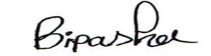Yours sincerely

…………………………….

BIPASHA RANI MONDOL