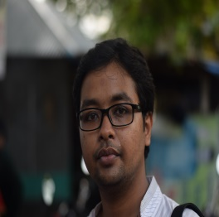

S. M. Abu Naser Shovon

B.Sc. in Mechanical Engineering

Bangladesh University of Engineering & Technology

|  |  |
| --- | --- |
| **Education** | |
| 2017 | Department of Mechanical Engineering,  BUET  GPA: 3.12 |
| 2012 | HSC  Kushtia Govt. College  Science  GPA: 5.00 |
| 2010 | SSC  Kushtia Zilla School  Science  GPA: 5.00 |
| **Skills**  Student Leadership  Team Management  Event Management  Technical Skills- Microsoft Word, Microsoft Excel, Microsoft PowerPoint  Application Tool- AUTO CAD, Solidworks,  **Language**  English [Fluent, Professional both in Reading & Writing]  Bengali[ Mother Tongue] | |

**Career Objective**

Confident & passionate about the work, improve personal skill & loyal with myself & the company.

**Address**

9, Wyre street, Wari, Dhaka-1203

**LinkedIn Profile**

**Sultana Moni**

**E-mail**

[samihabuet.12@gmail,com](mailto:samihabuet.12@gmail,com)

**Contact No.**

+8801687247901

|  |  |  |
| --- | --- | --- |
| **Major Courses** | | **Thesis** |
| 1. Engineering Mechanics  2. Power Plant Engineering  3. Machine Design  4. Industrial Management  5. Thermodynamics  6. Heat & Mass transfer | 7. Fluid Mechanics  8. Solid Mechanics  9. Composite Materials  10. Applied Math.  11. Machine Tools  12. Fluid Machinery  13. Fluidics | Gear Box of Epicyclic Gear Train(On going) |
| **Project** |
| Object Detecting Robot |

**Additional Experience**

1. Internship at Sanofi Bangladesh Limited. I have done 3 weeks of internship on operating, production, filling and packaging units.
2. Industrial Visit at Meghna Group of Industries, Energypac Bangladesh Limited, Milners Pump Limited and Ashuganj Power Company Limited.