Ratna Khatun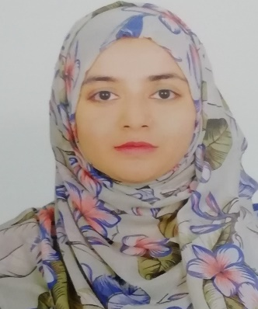

Mailing Address:

House No: 356, Naya Nagar (Cocacola road), Vatara, 1229

E-mail: nishatrahmantuli@gmail.com

Mobile: 01982486856

***Objective:***

Looking for a position in your organization where I can integer my acquired knowledge and key strength to add value to the organization’s corporate goal.

***Job Experience:***

|  |  |
| --- | --- |
| **Position** | Administrative officer |
| **Organization** | SEWROTCI (Under Ministry of Industry) |
| **Duration** | 11th March 2019 till present |
| **Responsibilities** | Loan approval, procurement, personal file maintain, office order prepare, performance measurement, field monitoring, member verification etc. |
| **Position** | Manager (Client Service) |
| **Organization** | Frontline Communications Limited |
| **Duration** | 18th August 2016 to 28th February 2019 |
| **Responsibilities** | Newcorporate client acquisition, maintain relationship with existing clients, generate business from corporate firm and training, leading, follow-up team members etc. |

***Academic Background:***

|  |  |
| --- | --- |
| **Year (2019):** | **Master of Business Administration [MBA]**  **Bangladesh Open** University  **Major:** Humane Resource Management  **Result**: Appeared |
| **Year (2016):** | **Bachelor of Business Administration [BBA]**  Bangladesh Open University  **Major:** Humane Resource Management  **Result**: CGPA:***2.73 (****on the scale of 4.0)* |
| **Year (2010):** | **Higher Secondary Certificate [H.S.C]** |
|  | Shatrujitpur Collage  **Group:** Business Studies  **Result:** GPA ***3.00 (****on the Scale of 5.00)* |
| **Year (2008):** | **Secondary School Certificate [S.S.C]** |
|  | Dhalahara Chandpur High School  **Group:** Business Studies  **Result:** GPA ***3.38 (****on the Scale of 5.00*) |

***Extra-Curricular Activities:***

Debate Champion- Topic: Freedom Fight (2009)

Hand Boll Champion in School Level and Thana Level & Runner up in District level.

***Computer Literacy:***

**Operating System** : Windows 7, Windows 8 & XP professional.

**Others program** : Microsoft word, Microsoft Excel, Microsoft Power Point, mail operation & Operation to Internet.

***Skills:***

* + Good communication ability.
  + Good command over Bangle and English
  + Willing to learn and grow by accepting responsibilities and direction.
  + Ability to work under pressure & ready to meet the challenges.
  + Good team worker.

***Special Interest:***

* Traveling, Cooking

***Personal Information:***

**Father’s name**  : Md. Abdur Rahman Mollah

**Mother’s name** : Lata Begum

**Permanent Address** : 386/ka, Noor Mahal, Kandipara, Brahmanbaria-3400

**Date of birth** : 21th September 1992

**Nationality** :Bangladeshi

**Sex** : Female

**Blood Group** : B+

***References:***

|  |  |
| --- | --- |
| **Mostaque Hassan NDC** | **Kaji Emdad** |
| Additional Secretary  Chairman of BSCCI | (Deputi Secretary)  District Commissioner (DC) |
| Contact No: 01914882145 | Sylhet |
|  | Contact No: 01712562856 |