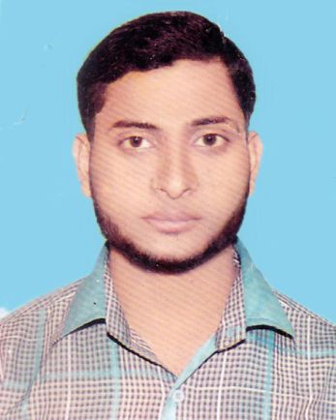***Bio-Data***

**Name : Md. Ibrahim Khalil**

Father’s Name : Abdus Sattar Sarker

Mother’s Name : Asma Begum

Permanent address : Vill- Shernagor, Post- Shernagor,

Police Station- Belkuchi, Dist.:Sirajgonj.

Present address : Vill- Shernagor, Post- Shernagor,

Police Station- Belkuchi, Dist.:Sirajgonj.

Date of birth : 19th February 1998

Sex : Male

Nationality : Bangladeshi

Religion : Islam

Marital Status : Unmarried

Height : 5`-8``

Weight : 55 KG

Blood group : B+(ve)

National ID No : 19988821108000002

Contact No : 01773-063753

Email : ibrahimkyamch@gmail.com

Educational Qualification :

|  |  |  |  |  |
| --- | --- | --- | --- | --- |
| Name of Exam | Passing Year | GPA/Division | Group | Board/University |
| S.S.C/Dakhil | 2014 | 4.94 | Science | Madrasha |
| H. S. C/Alim | 2016 | 4.50 | Science | Madrasha |
| Degree/Fazil | - | Appearing | B.A | Islimic University |

**Computer Literacy :**

6 Month Basic Computer Skill

**Md. Abdul Matin**

Date: