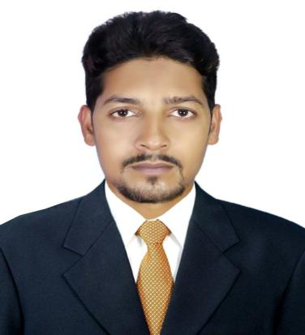

**Md. Naimur Rahman**

House #Ka-34 Post Office Road, Khikhet, Dhaka- 1229

Cell: +8801316-103719, +880 1912-635196

E‑mail: naimur44s@gmail.com

|  |  |  |
| --- | --- | --- |
| **Career Objective** | I would like to build up my career in EEE engineering profession that offers a challenging career & noble way of leading life and i want to be a part of a development organization which would utilize my educational background and skills to attain the organizational goals and develop my career. | |
| **Education** | 1. **B.Sc. in EEE:**University Of Information Technology and Science (UITS), Badda, Bangladesh.   **CGPA:2.89(on the scale of 4.0);**Passing year: 2017   1. **Diploma in Electrical:** Jamalpur Institute of Technology and Science (JIST), Jamalpur Sadar, Jamalpur, Bangladesh.   **CGPA:3.29 (on the scale of 4.0),**Passing year: 2010   1. **Dhakal:**Dawanganj Kamil Madrasha, Jamalpor –Dawanganj, Jamalpor, Bangladesh.   **CGPA :4.00 (on the scale of 5.0);**Passing year: 2006 | |
| **Job experience** | * **Company Name** :Ezzy Automation Ltd.   **Name of the post** : “Executive”.  **Location** : *House 214, Road 13, New DOHS, Mohakhali, Dhaka.*  **Duration**  : 02 Nov 2019 to Continue..  **Responsibilities** : Watchman/GSM camera, CCTV, UPS, IPS, after sales support, Customer relation maintains, Hard work for create my place.   * **Company Name** :Bee Technology Ltd.   **Name of the post** :“System Engineer”.  **Location** : *Road 9, House 18, House Building, Uttora, Dhaka.*  **Duration**  : 02 Feb 2017 to 15 Oct 2019  **Responsibilities** : GP network testing (Drive Testing) DT project in one year 20 District one by one upazila work for BTCL. Rural area GP tower maintains or Upgrade 2G, 3G, 4G/LTE networks. Link alignment one BTS to others. Using huawei and ericsion equipment. All this telecommunications work learn, gainer, gather match batter experience.   * **Company Name** :Partex Group.   **Name of the post** :“Sales & Service Engineer”.  **Location** : *74 Mohakhali C/A, Dhaka 1212*  **Duration**  : 05 Jul 2013 to 15 Jan 2017  **Responsibilities** : Love Each Other (LEO) promote and import in Bangladesh partex group in the year 2013 I work here as a sale and service engineer. Jet pumps, centrifugal pumps, submersible pumps sales and after service. | |
| **Training** | * 6 Month Training on Transformer **”Centre Equipment Repairing Shop (CERS)”- Cheragali, Tongi, Gazipur, Dhaka.** That was a great time I was seen the biggest transformer in my life it was 420 KV. I learn here transformer core setup, coil winding, tap changing, insolating, heating. Winding resistance test, ratio test, vector group test and transformer protection system.   6 Month Training on Electrical & house Wiring Trade **“Department Of Youth Development” – Jamalpur Sadar, Jamalpur, Bangladesh.** |
| **Computer Skills** | **Operating System**: Windows, Linux, Ubuntu, XP, etc.  **Application Software**: MS Office (Word, Excel, Power point), Photoshop, Internet browsing, Computer applications.  **System Knowledge**: Setup hardware in a desktop PC, Install software in a laptop/desktop PC,  Repair basic troubleshooting.  **EEE Engineering**:Electrical protection system, Electrical Circuit diagram, Electrical Symbol. | |
| **Communications** | | * Good command in English communication * Dynamic and strong interpersonal skill. * Good ability to make warm relationship with people | |
| **Personal Information** | * **Father's name** Md. Abdul Karim * **Mother's name** Mrs. Suraya Begum * **Village**  Banararpur * **P.O** Banararpur * **P.S** Jamalpur * **District** Jamalpur * **Date of Birth** 1stNov 1991. * **Marital Status**Married * **Nationality** Bangladeshi. * **National ID** 2388840510. * **Religion** Islam | |
|  |  | |
| **References** | **Sad Bin Hassan Sadi**  Asst. Manager, Lead (ASS)  After Sales Service  Ezzy Group  Mobile : 01844-143441  **Dr. Engr. Mizanur Rahman**  Associate professor & Dean  Head of EEE Dept.  University Of Information Technology and Science (UITS), Badda, Bangladesh.  Mob: +8801923-156445 | |

Capture.JPGSignature