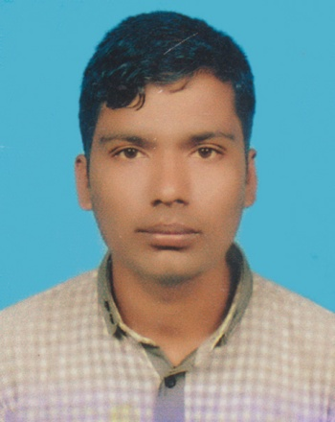**CURRICULUM VITAE**

***of***

**Md. Rubel Islam**

**Mailing Address**

House-B-1/14, BADC Staff Quarter,

Tolarbagh, Mirpur-1, Dhaka-1216.

Cell: +88 01778951616

Email: rubel017789@gmail.com

**Career Objective**

Looking forward to take challenges & work hard with sincerity & hence enhance skill to contribute to institutional development & bring personal fulfillment.

**Academic Profile**

**Bachelor of Business Administration (BBA)**

Institute : Dhaka New Model Degree College

Department : Management

University : National University

Passing : 2nd Year Running

**Higher Secondary Certificate (H.S.C)**

Institute : Thakurgaon Road Degree College

Group : Business Studies

Board : Dinajpur

Result : 2.83

Passing Year : 2018

**Secondary School Certificate (S.S.C)**

Institute : Sarali Adarsha High School

Group : Science

Board : Dinajpur

Result : 3.89

Passing Year : 2016

**Computer Skills**

* Computer Office Application (MS Word, MS Excel & Internet Browsing).

**Experience**

* I am worked as POS in Prince Bazar from 01/03/2018 and Pran RFL Tasty Treat 2nd Incharge 2 year experienc.

**Language Proficiency**

* Bangla Mother Language
* English Reading , Writing and speaking Ability

**Additional Attributes**

* Sincere and devoted to duties.
* Hard working disciplined and steady.
* Better ability to take the duties, responsibilities and pressures.
* Keen eyesight and better sound analytical ability.

**Personal Profile**

Name :  **Rubel Islam**

Father’s Name : Abdur Rahman

Mother’s Name : Rajina Begum

Date of Birth : 17/12/1999

Religion : Islam

Nationality : Bangladeshi by Birth

Marital Status : Unmarried

Gender : Male

Blood Group : A+ (ve)

Height : 5-6 Inch

Weight : 53 kg

**Permanent Address**

Vill- Sarali, P.O- Shibgonj,

P.S- Thakurgaon Sadar, Dist- Thakurgaon.

**Declaretion**

I hereby declare that all the information stated above is correct and I have all the necessary documents to support the information have provided.

**(Rubel Islam)**

Date :